CHEMISTRY NOTES

Table of Contents

*GLOSSARY/TERMS 3

PURE SUBSTANCES AND MIXTURES 3

PHYSICAL AND CHEMICAL PROPERTIES 4

NANOPARTICLES AND NANOMATERIALS 4

SEPARATION TECHNIQUES 6

ATOMIC STRUCTURE/ATOMIC THEORY 9

THE 3 SUBATOMIC PARTICLES 14

ISOTOPES, MASS NUMBER AND ATOMIC NUMBER 15

FORMULAS OF IONS AND MOLECULES (+ POLYATOMIC IONS) 16

RELATIVE ATOMIC MASS 16

CONVERTING TO NANOMETRES 18

MASS SPECTROMETRY 18

ELECTRON CONFIGURATION 19

PERIODIC TABLE TRENDS 21

EMISSION AND ABSORPTION SPECTRA 25

SPECTROSCOPY 25

BONDING 27

*IONIC COMPOUNDS + IONIC BONDING 27

METALLIC BONDING 30

*COVALENT BONDING 32

*ORGANIC CHEMISTRY 36

HYDROCARBONS 36

ALKANES 37

NAMING ALKANES 39

REACTIONS OF ALKANES (CHEMICAL PROPERTIES) 41

ALKENES 41

NAMING ALKENES 41

REACTIONS OF ALKENES 42

FORMULA AND MOLECULAR MASS 42

THE MOLE AND NUMBER OF PARTICLES 43

MOLAR MASS AND PERCENTAGE COMPOSITION 44

MOLAR MASS, MASS AND MOLECULES 44

STOICHIOMETRY 45

MISC NOTES – REACTIONS OF HYDROCARBONS 45

ENERGY AND CHEMICAL REACTIONS 47

FUELS 51

FUELS 52

INTERMOLECULAR FORCES 54

ELECTRONEGATIVITY AND POLARITY 56

INTRAMOLECULAR + INTERMOLECULAR 56

GASES 59

HLPC AND GAS CHROMATOGRAPHY 62

WATER 65

SOLUTIONS 67

ACIDS AND BASES 73

REACTION RATES 77

TYPES OF CATALYSTS 85

unit one

# *GLOSSARY/TERMS

Density: density is a measure of the mass per unit of volume of a substance

Isotopes: elements with the same atomic number but different mass number or the same number of protons but a different number of neutrons

Example: H-1, H-2, H-3

Ion: ----

Cation: ----

Anion: ----

Atomic number: number of protons

Mass number: protons + neutrons (nucleus)

Element: made up of one type of atom, cannot be separated by chemical change into simpler substances, can be classified as covalent molecular elements, covalent network elements and metallic elements

Compound: ---- is made of **different** elements

Molecule: ---- single atoms??

Homogenous mixture: have uniform composition and properties throughout (e.g. a solution made up of a solvent + solute, an alloy. Made up of 2 or more metals – bronze is a mixture of copper and tin (and possible other metals))

Heterogeneous mixture: not uniform in composition and properties throughout (e.g. granite)

Polyatomic ions: ----

Ionic compounds: ----

Monatomic ion: an ion made of 1 atom

Combustion reaction: combustion reactions – a reaction with oxygen that releases energy (an exothermic reaction).

Aqueous:

Allotropes: same element but they have different structures

Cation + Anion bond together = ionic compound

Ductile

Malleable

# PURE SUBSTANCES AND MIXTURES

PURE SUBSTANCES

Consist of matter that has a definite, fixed composition

* They are classified as elements or compounds
  + Elements = made up of one type of atom, cannot be separated by chemical change into simpler substances, can be classified as covalent molecular elements, covalent network elements and metallic elements
  + Compounds = pure substances composed of 2 or more elements chemically combined, in a fixed ratio, they have a chemical formula which indicates the ratio of the elements found in the compound, can be classified as ionic compounds, covalent molecular compounds and covalent network compounds

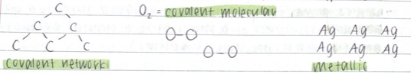



MIXTURES

Matter composed of two or more pure substances

* Mixtures can contain different proportions of the same component substances
* They can be homogeneous or heterogeneous
  + Heterogeneous mixtures = not uniform in composition and properties throughout (e.g. granite)
  + Homogeneous mixtures = have uniform composition and properties throughout (e.g. a solution made up of a solvent + solute, an alloy. Made up of 2 or more metals – bronze is a mixture of copper and tin (and possible other metals))

# PHYSICAL AND CHEMICAL PROPERTIES

PHYSICAL PROPERTIES

* Melting point (temperature that a solid turns to liquid)
* Boiling point (temperature that a liquid turns to a gas)
* Hardness (resistance of a material to a change of shape)
* Density (mass per unit of volume)
* Pure substances have a fixed composition, therefore the amount of energy required to cause a change of state is well defined and constant
* A mixture (such as seawater) will have varying boiling or melting points depending on the proportion of substances present
* The same can be said for density and hardness, as well as other physical properties

CHEMICAL PROPERTIES

* Refers to the ability of a substance to react and form a new substance
* A pure substance will have well defined reactivity (e.g. iron corroding in presence of oxygen and water to form rust)
* A mixture will have varying reactivity (e.g. steel, an alloy of iron and other metals, does not react to form rust (as easily) depending on the proportions of the metals present

# NANOPARTICLES AND NANOMATERIALS

NANOPARTICLES

* A nanometer (nm) is one billionth of a meter (10-9m)
* The nanoscale refers to a length scale between 1 – 100 nm
* Nanomaterials are materials made up of nanoparticles (particles on the nanoscale)
* Nanotechnology investigates the design, properties and application of nanomaterials

NANOMATERIALS

* Can be natural or synthetic
* A picture containing game

  Description automatically generatedMetal-based nanomaterials include: quantum dots, nano-gold, nano-silver and some metal oxides such as ZnO and TiO2
* Carbon nanotubes are another nanomaterial made up of lattices of carbon atoms, forming tubes (image on right)
* They are tiny, but physically strong and can act as conductors of electricity

PROPERTIES OF NANOPARTICLES

* Nanoparticles have unique properties which can differ from the bulk material
* The small size of the nanoparticles means the properties of nanomaterials are related to the quantum effects of the particles
* They also have a large surface area and increased reactivity
* E.g. A physical property of bulk gold is its shiny yellow colour, however, nano-gold appears reddish in colour

PRODUCTION OF NANOPARTICLES

* Top-down method:
  + Break down bulk material into nanoparticles
  + Only provides particles for simple structures
* Bottom-up method:
  + Build materials ‘atom-by-atom’ or ‘molecule-by-molecule’
  + Manipulate atoms at the nanoscale
  + Can build complex structures from nanoparticles

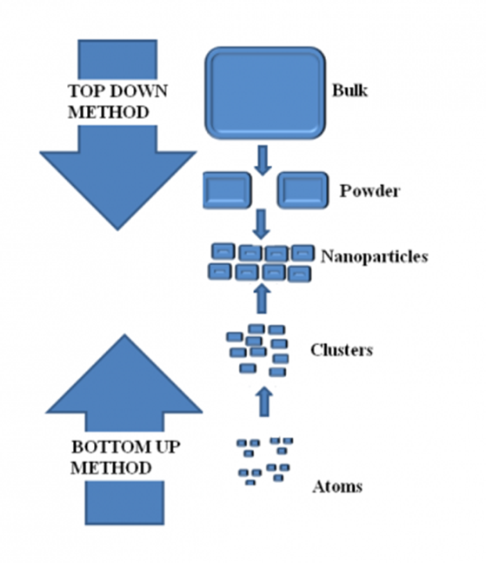

# SEPARATION TECHNIQUES

Obtaining pure substances from a mixture:

* Mixtures can be separated based on differences in physical properties, such as:
  + Particle size
  + Boiling point
  + Solubility
  + Density
  + Magnetic field
  + Electric charge

FILTRATION

* Used to separate solid particles from a liquid or gas
  + Most common form of filtration in the lab involves filter paper
    - A liquid/solution containing a solid is poured into filter paper
    - The liquid passes through the filter paper and becomes the filtrate
    - The solid is trapped by the filter paper and becomes the residue
* This technique works based on particle size and solubility
  + The sand is too big of a particle to fit through the paper
  + The sand isn’t soluble so it doesn’t dissolve into the water

CRYSTALLISATION/EVAPORATION

* Separates part of a solution – solute from the solvent
  + Liquid is turned to vapour by boiling the solution (or allowing it to evaporate)
  + This leaves behind a solid – the solute from the solution
* This technique works based on differences in boiling point
  + The solvent has a much lower boiling point than the solute

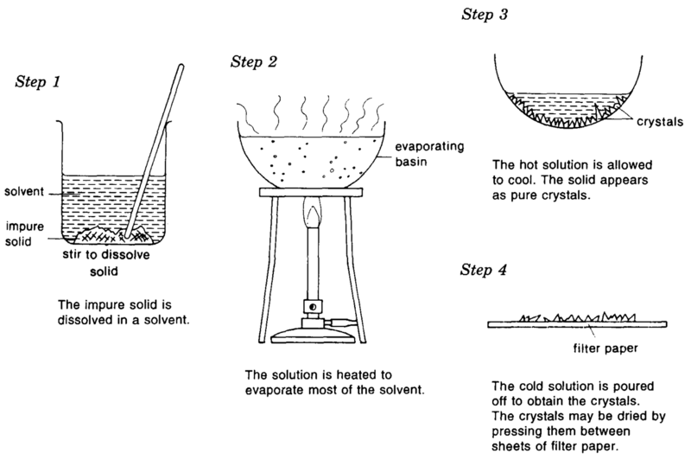

DISTILLATION

* Used to separate 2 or more liquids, or a liquid from a solid in a solution
  + A mixture is placed in a round-bottom flask and heated to boiling
  + The vapour produced passes through a condenser, turns back to liquid and is collected – this liquid is called the distillate
  + This process is sometimes called simple distillation
* This technique works based on differences in boiling point
  + The substance with the lower boiling point will become vaporised, and condense to form a liquid
  + The substance with the higher boiling point will remain in the flask
  + Simple distillation only works if the boiling points have quite a large difference

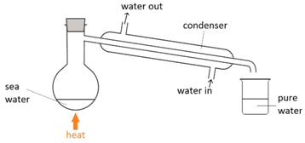

FRACTIONAL DISTILLATION

* Fractional distillation uses the same principles as simple distillation, but can separate mixtures of liquids with boiling points that are close together
  + The vapour travels up a fractioning column and as it comes into contact with the material packed into the column, it will condense, and then evaporate again
  + The condensation-evaporation process repeats again and again up the column
* This increases the amount of the chemical with the lower boiling point making its way up the fractionating column, while the chemical with the higher boiling point will condense back into the flask

CHROMATOGRAPHY

* A mixture is dissolved in a solvent, and then it travels through a different material (such as filter paper)
* The different components of the mixture travel at different speeds, causing them to separate
* E.g: separating out the different colours in ink using paper chromatography

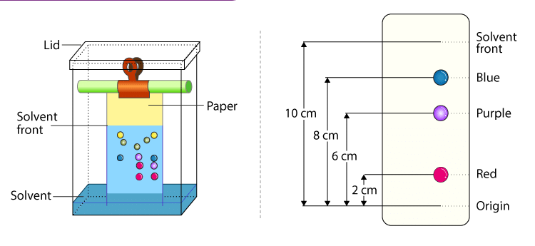

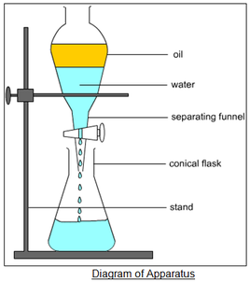SEPARATION FUNNELS

* If two liquids have different densities and are immiscible liquids (don’t mix) then they can be separated by a separation funnel
* When immiscible liquids are placed in the flask, two layers will form
* The more dense liquid pours out the funnel bottom when the tap is opened

CENTRIFUGATION

* Speeds up sedimentation and helps to extract finer particles that may not settle out naturally
* Spinning the mixture pushes the denser particles to the sides because of centrifugal force

ELECTROSTATIC SEPARATION

* Positive and negative charges attract
* The force of attraction between opposite charges is known as the electrostatic force and can be used to separate charged particles from uncharged particles
* Electrostatic filters use the electrostatic force to separate solid particles from a gas

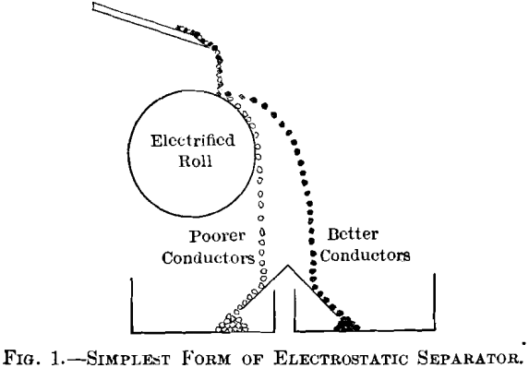

MAGNETIC SEPARATION

* Using magnetic fields to separate components by using magnets to attract magnetic particles
* Passing a magnet over allows the magnetic particles to attract to the magnet and all the non-magnetic particles to remain

# ATOMIC STRUCTURE/ATOMIC THEORY

ATOMS

* Atoms are the smallest unit of elements that maintain the properties of the element
* Our understanding of the structure of atoms has developed over many centuries, and is still developing
* A key contributor to our current model of the atom was John Dalton

Dalton’s theory can be summarised into the following points:

* Elements consist of tiny indivisible particles called atoms
* All atoms of the same elements are identical and therefore have the same mass and properties
* Compounds are formed when 2 or more different atoms combine in a fixed ratio
* Atoms are conserved in a chemical reaction

ATOMIC STRUCTURE

* Atoms are made of smaller, subatomic particles and a lot of empty space
* There are 3 types of subatomic particles:
  + Protons
  + Neutrons
  + Electrons
* Atoms have 2 distinct regions. The central nucleus and the space around the nucleus
* The electrons are in constant movement, orbiting the nucleus
* The electrostatic attraction between the positively charged nucleus and the negatively charged electrons keep the electrons moving about the nucleus

ATOMIC STRUCTURE – HISTORY

* Dalton, Thomson, Rutherford, Bohr, Chadwick

SUMMARY:

|  |  |  |  |  |  |
| --- | --- | --- | --- | --- | --- |
| YEAR | NAME | DISCOVERY | EXPLANATION | EXPERIMENT | MODEL |
| 1803 | John Dalton | All matter is made from atoms | N/A | Mixed gases + pressure of steam | Solid sphere model  Image result for what was the name of john daltons model |
| 1904 | JJ Thomson | Electrons | the atom could be divided into smaller parts and that atoms contained small negative particles called an electron | cathode ray tubes + alpha particles | Plum Pudding Model  Image result for plum pudding model |
| 1911 | Ernest Rutherford | The nucleus | most of an atom must be empty space to allow the majority of the alpha particles to pass through it – most of the mass of an atom and its positive charge must be located in a tiny, central region | gold foil experiment | Nuclear Model   |
| 1913 | Niels Bohr | electrons travel in separate orbit around the nucleus | electrons travel in separate orbits around the nucleus and that the number of electrons in the outer orbit determines the properties of an element | wavelengths of the atoms | Planetary Model   |
| 1932 | James Chadwick | The neutron | He fired alpha particles at beryllium, and noticed that (relatively) large neutral particles were released. Through further experiments, he concluded the particles were the same mass as protons, with a neutral charge and were found in the nucleus | Beryllium and alpha particles experiment | Chadwick model   |

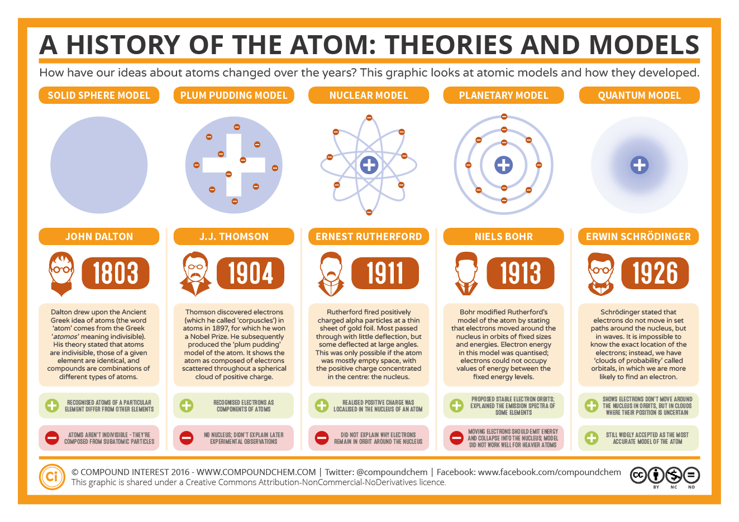

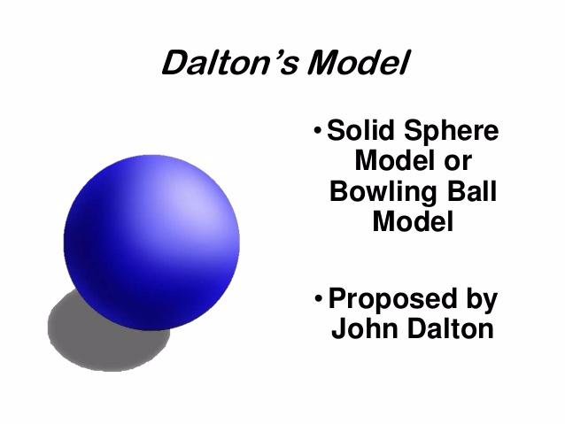John Dalton (1803)

Dalton’s atomic theory proposed that all matter was composed of atoms, indivisible and indestructible building blocks. While all atoms of an element were identical, different elements had atoms of differing size and mass.

* Experiment: mixed gases and the pressure of steam
* Discovered that all matter is made of atoms (the smallest building blocks)
* Dalton’s atomic model (Solid sphere model or bowling ball model)

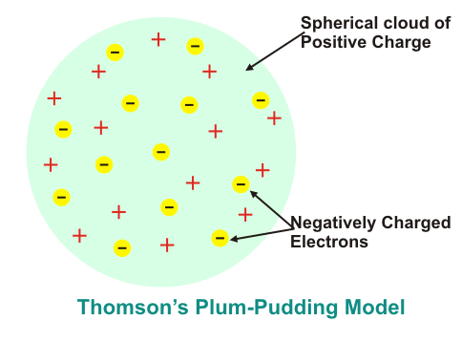JJ Thomson (1904)

Proposed that the atom could be divided into smaller parts and that atoms contained small negative particles called an electron

* Experiment: cathode ray tubes + alpha particles
* Discovered the electron
* Plum pudding model
  + The negatively charged particles are spread throughout the positively charged sphere of the atom like raisins in a plum pudding

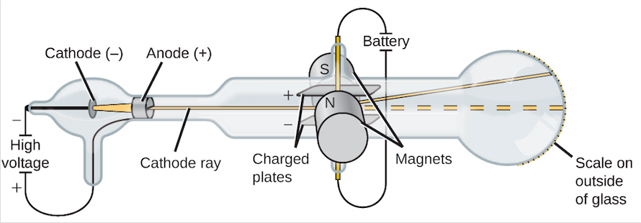

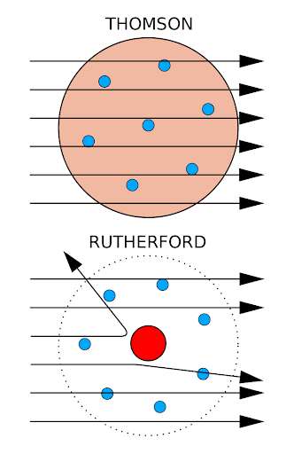Ernest Rutherford (1911)

Concluded that most of an atom must be empty space to allow the majority of the alpha particles to pass through it – most of the mass of an atom and its positive charge must be located in a tiny, central region

* Experiment: gold foil experiment
* Discovered the nucleus of an atom
* The planetary (Rutherford) model

Niels Bohr (1915)

He discovered that electrons travel in separate orbits around the nucleus and that the number of electrons in the outer orbit determines the properties of an element. He also stated that the orbits are at certain distances from the nucleus with set amounts of energy. These locations were called electron shells (the location), or energy levels (how much energy that shell has)

* Experiment: wavelengths of the atoms
* Discovered that electrons travel in separate orbit around the nucleus
* The Rutherford- Bohr model/Bohr model

(The Bohr model of the atom is based on Bohr’s work with the hydrogen atom. When energy is put into an atom, electrons are able to move further away from the nucleus. However, this is very unstable, and so the electrons quickly return to their original location, releasing energy. This released energy can be seen as light, and the frequency of the light can be measured. This produces a line emission spectra. Bohr found that only certain quantities of energy were released, therefore he concluded that the electrons were only found in certain locations.)

James Chadwick (1932)

He fired alpha particles at beryllium, and noticed that (relatively) large neutral particles were released. Through further experiments, he concluded the particles were the same mass as protons, with a neutral charge and were found in the nucleus

* Experiment: Beryllium and alpha particles experiment
* Discovered the neutron
* The James Chadwick atomic model

# THE 3 SUBATOMIC PARTICLES

Protons

* Are located in the nucleus of an atom
* The number of protons is unique for atoms of a particular element
* The number of protons is called the atomic number or Z number
* Protons have:
  + A relative mass of 1
  + An actual mass of 1.673x10-27kg
  + A relative charge of +1 (positive)

Neutrons

* Neutrons are also located in the nucleus of an atom
* The number of neutrons can vary between atoms of the same element
* Atoms of the same element with different numbers of neutrons are called isotopes
* The number of protons + neutrons is called the mass number or A number
* Neutrons have:
  + A relative mass of 1
  + An actual mass of 1.675x10-27kg
  + A relative charge of 0 (no charge)

Electrons

* Electrons are located around the nucleus of an atom
* In a neutral atom the number of electrons is the same as the number of protons
* Atoms are able to lose or gain electrons
* When this happens they have a net charge and are called ions
* Electrons have:
  + A relative mass of 1/2000
  + An actual mass of 9.110x10-31kg
  + A relative charge of -1 (negative)

# ISOTOPES, MASS NUMBER AND ATOMIC NUMBER

Isotopes: atoms of the same element with different numbers of neutrons

Atomic number: number of protons

Mass number: protons + neutrons (nucleus)

Isotopes

* isotopes of the same element have similar or the same chemical properties (how they react)
* however, physical properties – such as mass and density – may differ
* some isotopes have a significant difference in number of neutrons and protons
  + these isotopes have unstable nuclei and are radioactive (they undergo radioactive decay)

Example:

Carbon (c) – there are 3 carbon isotopes

* Carbon – 12
* Carbon – 13
* Carbon – 14

= all isotopes of carbon

We can represent atoms/isotopes like:

or AX

or X-A

* If the atom has no charge then the number of electrons = the number of protons

EXAMPLES

find protons, neutrons and electrons for:

a) $\begin{matrix}12 \\ 6\end{matrix}C$

protons = 6

neutrons (mass number – protons) = 6

electrons = 6

b) 40Ar

* look on periodic table for the mass number = 18

protons = 18

neutrons = 22

electrons = 18

c) Zn-66

* look on period table for mass number = 30

protons = 30

neutrons = 36

electrons = 30

# FORMULAS OF IONS AND MOLECULES (+ POLYATOMIC IONS)

|  |  |  |  |  |
| --- | --- | --- | --- | --- |
| POSITIVE ION | FORMULA |  | NEGATIVE ION | FORMULA |
| Ammonium | NH4+ | Bromide | Br- |
| Caesium | Cs+ | Chloride | Cl- |
| Hydrogen | H+ | Cyanide | CN- |
| Lithium | Li+ | Dihydrogenphosphate | H2PO4- |
| Potassium | K+ | Ethanoate (acetate) | CH3COO- |
| Rubidium | Rb+ | Fluoride | F- |
| Silver | Ag+ |  | Hydrogencarbonate | HCO3- |
| Sodium | Na+ | Hydrogensulfate | HSO4- |
| Barium | Ba2+ | Hydroxide | OH- |
| Calcium | Ca2+ | Iodide | I- |
| Cobalt(II) | Co2+ | Nitrate | NO3- |
| Copper(II) | Cu2+ | Nitrite | NO2- |
| Iron(II) | Fe2+ | Permanganate | MnO4- |
| Lead(II) | Pb2+ | Carbonate | CO32- |
| Magnesium | Mg2+ | Chromate | CrO42- |
| Manganese(II) | Mn2+ | Dichromate | Cr2O72- |
| Nickel(II) | Ni2+ | Hydrogenphosphate | HPO42- |
| Strontium | Sr2+ | Oxalate | C2O42- |
| Zinc | Zn2+ |  | Oxide | O2- |
| Aluminium | Al3+ | Sulfate | SO42- |
| Chromium(III) | Cr3+ | Sulfide | S2- |
| Iron(III) | Fe3+ | Sulfite | SO32- |
|  | | Nitride | N3- |
| Phosphate | PO43- |

# RELATIVE ATOMIC MASS

* scientists measure mass relative to carbon-12, the most common carbon isotope
* C-12 was given the value of 12 units
* ∴ 1 unit of mass on this scale = $\frac{1}{12}$ the mass of C-12
  + ∴ 1amu (atomic mass unit) = $\frac{1}{12}$ the mass of C-12
* The individual mass of an isotope is called the relative isotopic mass
* The relative isotopic mass is very close to, but not the same as, the mass number for a given isotope
  + Example: Cl-35 has an isotopic mass of 34.969amu

RELATIVE ATOMIC MASS (Ar)

* The relative atomic mass of an element is the weighted average of all isotopic masses, based on their % abundance

example: find the relative atomic mass of silver, based on the following information:

|  |  |  |
| --- | --- | --- |
| ISOTOPE | ISOTOPIC MASS | % ABUNDANCE |
| Ag-107 | 106.9 | 51.8 |
| Ag-109 | 108.9 | 48.2 |

$$A_{r}=\frac{\left(\% × isotopic mass\right)}{100}$$

$$A_{r}=\frac{\left(51.8×106.9\right)+(48.2×108.9)}{100}= 107.864 ≈107.9amu$$

*note: sometimes questions/calculations will use mass number instead of relative isotopic mass

EXAMPLE

Ar of Rubidium is 85.47. Isotopic masses of 85Rb and 87Rb are 84.95 and 86.94

Calculate relative abundances of each isotope

Working:

Abundance of 85Rb = x, abundance of 87Rb = 100-x *\*this is because they will add to 100%*

$$A_{r}=\frac{\left(\%× isotopic mass\right)}{100}$$

*Sub in what you know:

$$85.47=\frac{\left(84.95x\right)+(86.94\left(100-x\right))}{100}$$

$$85.47=\frac{84.95x+8694-86.94x}{100}$$

$$8547=84.95x+8694-86.94x$$

$$8547-8694= 84.95x-86.94x$$

$$-147=-1.99x$$

$$x=\frac{-147}{-1.99}$$

∴ abundance of 85Rb = 73.87%

∴ abundance of 87Rb = 100-73.87 = 26.13%

# CONVERTING TO NANOMETRES

# MASS SPECTROMETRY

e.g Ne

Lighter ones hit here

Heavier ones hit here

Become positively charged

Lighter ones at the bottom since they get deflected more and the heavier ones are at the top because they get deflected less

Move faster

Knock off electrons from the vaporised sample

∴ creates cations

THE FUNCTION OF A MASS SPECTRONOMETER

* Determines the mass of each isotope in a given sample of an element
* Calculates the relative abundance of each isotope in a given sample of an element

STEPS IN MASS SPECTROMETRY

* Vaporisation
  + The sample is turned to vapour/gas
* Ionisation
  + High energy electron beams collide with the vapour
  + This makes the atoms lose electrons and gain a charge (usually +1 – cation)
* Acceleration
  + An electric field accelerates the positive ions
* Separation
  + The ions pass through a magnetic field and are separated based on their mass/charge ratio (m/z ratio)
  + The lighter ions will be deflected more by the magnetic field (travel in a smaller radius)
* Detection
  + The amount of deflection is measured to determine m/z ratio (and therefore isotopic mass)
  + The number of ions that strike the detector are also measured to give the isotopic abundance

TABLE EXAMPLE

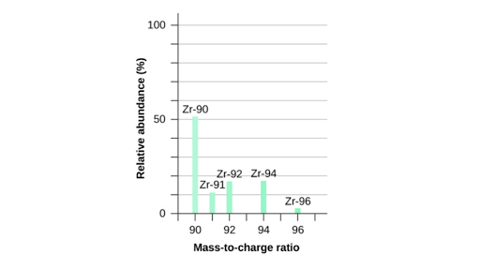

# ELECTRON CONFIGURATION

* The electron configuration shows the arrangement of electrons in an atom (or ion)
* The number of electrons that can fit in a shell or energy level is calculated by:

Number of electrons = 2n2

Where n = the number of the electron shell

* Therefore, the maximum electrons in:
  + 1st energy level = 2
  + 2nd energy level = 8
  + 3rd energy level = 18
  + 4th energy level = 32
  + And so on…
* The electrons will fill the lowest energy levels first
* 2, 8, 8, 2
* After the first 20 elements, it gets a bit more complicated so you will only have to know up to the first 20 elements
* Electrons in the outer shell/energy level are called valence electrons
  + These electrons require the least amount of energy to be removed from the atom
  + Valence electrons are involved in chemical reaction
  + Therefore if you know the valence electrons you can determine chemical properties of an element

EXAMPLES:

Na (Sodium) has 11 electrons

= 2, 8, 1

C (Carbon) has 6 electrons

= 2, 4

S (Sulfur) has 16 electrons

= 2, 8, 6

K (Potassium) has 19 electrons

= 2, 8, 8, 1

F (Fluorine) has 9 electrons

= 2, 7

ELECTRON CONFIGURATION FOR IONS

* We can write the electron configuration for ions by considering the number of electrons it will have

1. Use the atomic number to determine the number of electrons in a neutral atom
2. For a positive ion, subtract the charge from the number of electrons in a neutral atom
3. For a negative ion, add the size of the charge to the number of electrons in the neutral atom

EXAMPLES:

Mg2+ - 12 electrons if it is neutral, the ion then has 12-2=10 electrons

∴ the electron configuration is 2, 8

Li+ - 3 electrons if it is neutral, the ion then has 3-2 electrons

∴ the electron configuration is 2

P3- - 15 electrons if it is neutral, the ion then has 15+3=18 electrons

∴ the electron configuration is 2, 8, 8

Al3+ - 13 electrons if it is neutral, the ion then has 13-3=10 electrons

∴ the electron configuration is 2, 8

F- - 9 electrons if it is neutral, the ion then has 9+1=10 electrons

∴ the electron configuration is 2, 8

# PERIODIC TABLE TRENDS

ELECTRON ARRANGEMENT

(number of shells/energy levels)

ENERGY LEVELS

* The arrangement and number of electrons in an atom determines the chemical properties of the atom
* The electrons are located in energy levels or electron shells surrounding the nucleus
* The period number on the periodic table tells us how many energy levels there are for the atoms in those periods

VALENCE ELECTRONS

* The number of valence electrons from the groups 1,2 and 13-18 can be determined from the periodic table
* Group 1 elements have 1 valence electron
* Group 2 elements have 2 valence electrons
* Groups 13-18 have 3-8 valence electrons (except for helium which has 2)

ATOMIC RADIUS

* Atomic radius refers to the distance from the nucleus to the valence-shell electrons
* The atomic radius of an atom or ion is dependent on the:
  + number of electrons in the atom
  + shells in which these electrons are located
  + charge on the nucleus of the atom

Important Notes: Core charge & shielding

* The effective positive charge experienced by the valence or outer-shell electrons in the atom is the core charge
* Electrons in the inner shells of an atom are thought to have a shielding or cancelling effect of the positive charge on the nucleus (because they repel the outer electrons)

Trend 1: atomic radius increases down a group

* As the number of energy levels increases the distance between the valence shell and the nucleus will increase
* The electrostatic attraction between the positive charge of the nucleus and the valence electrons is weaker because the valence electrons are further away

Trend 2: atomic radius decreases across a period

* As the no. of protons increases, the positive charge in the nucleus will increase
* The number of electron shells will stay constant as the number of electrons in the valence shell increases
* Therefore, the negative valence electrons and the positive nuclear charge experience a stronger electrostatic attraction
* This pulls the electron cloud in – decreasing the radius

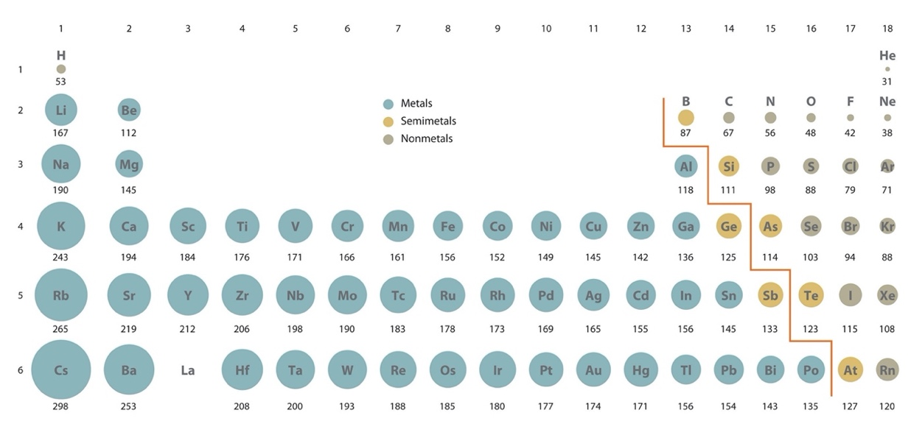

FIRST IONISATION ENERGY

* Ionisation energy is the amount of energy needed to remove an electron
* The first ionisation energy is the energy required to remove the first valence electron from an element in its gaseous state
* The lower the ionisation energy, the easier it is to lose electrons

Trend 1: First ionisation energy decreases down a group

* More electron shells means the negative electrons are further away from the positive nucleus, therefore less attracted to the nucleus and easier to lose

Trend 2: First ionisation energy increases across a period

* As you move across the period, the no. of protons increases, therefore the positive charge increases
* However, the number of electron shells stays the same
* Therefore the attraction between the positive nucleus and negative valence electrons gets stronger, so it becomes harder to remove an electron

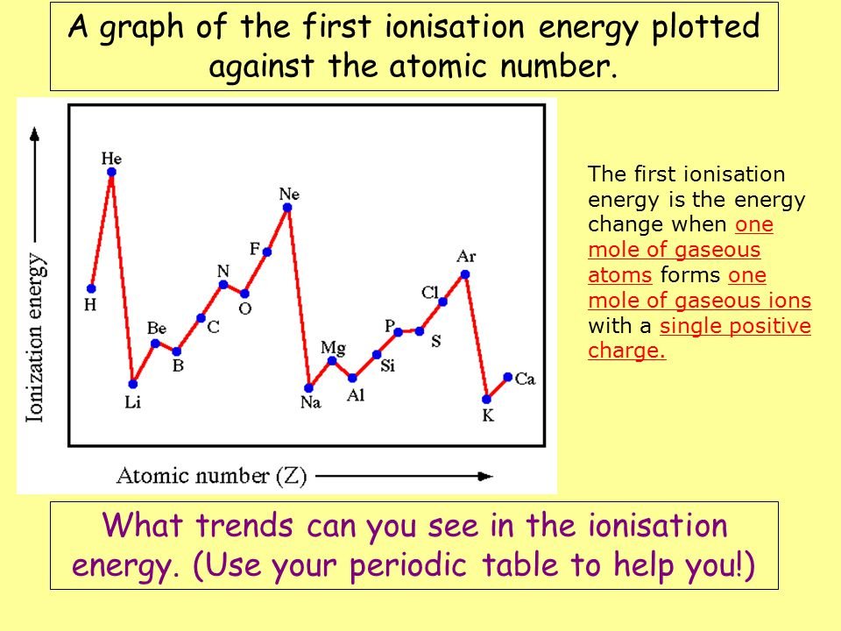

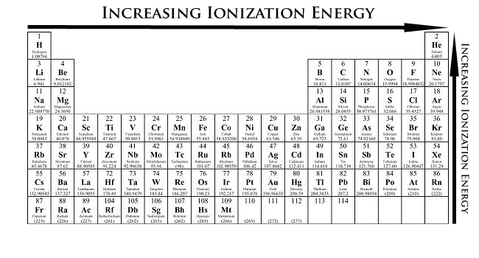

ELECTRONEGATIVITY

* Electronegativity is the ability of an atom to attract electrons and form bonds

Trend 1: electronegativity decreases down a group

* As the number of energy levels increases, the atomic radius increases
* Therefore the valence electrons are less attracted to the positive nucleus
* Therefore ability to attract electrons from other atoms decreases as well

Trend 2: electronegativity increases across a period

* The nucleus is becoming more positive due to increasing no. of protons
* The atomic radius decreases and the atom gets smaller, the valence electrons are strongly attracted to the nucleus
* This strong attraction (due to increased core charge) can attract electrons of nearby atoms

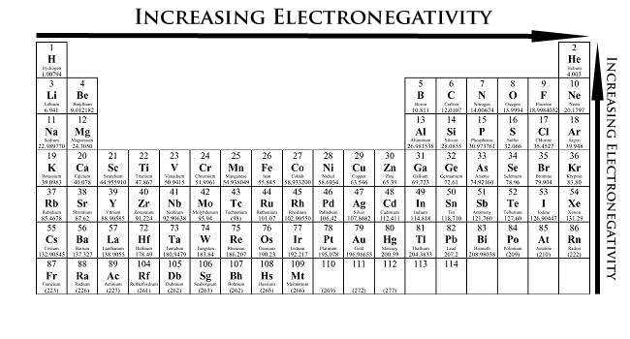

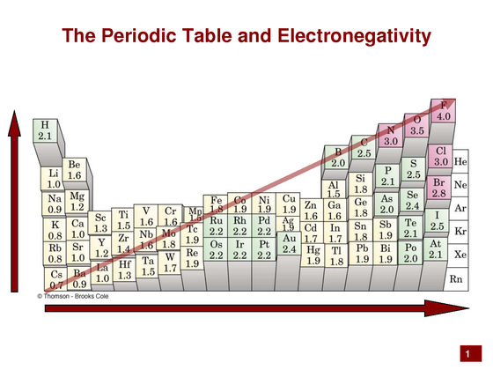

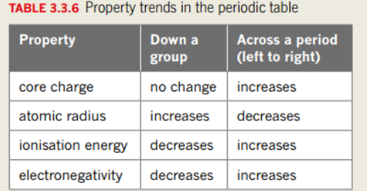

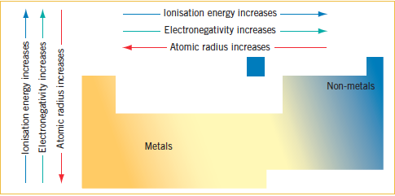

# EMISSION AND ABSORPTION SPECTRA

GROUND STATE AND EXCITED STATE

* When the electrons are filling the lowest energy levels, we say that the atom is in its ground state
* When there is 1 or more electrons that have jumped to a higher energy level (if energy was put into the atom), then we say that it is in its excited state
* For example:
  + The ground state electron configuration for Boron is 2, 3. If the electron configuration was given as 2,2,1 then we know that it is in an excited state

$$∆E=2nd shell-1st shell$$

E=energy

EMISSION SPECTRA

* Visible light is part of the electromagnetic spectrum, and different colours have different frequencies, wavelengths and energies
* When electrons return to their ground state they release the extra energy (that they absorbed to allow them to move into an excited state) in the form of visible light
* The amount of energy is determined by the difference in energy between the higher and lower energy levels
* Each element will produce a certain set of lines on an emission spectrum due to the unique set of possible energy levels that the electrons can move between
  + This is a given element’s line emission spectrum

ABSORPTION SPECTRA

* When electrons jump into a higher energy level, the amount of energy absorbed is equal to the difference in energy between the higher and lower energy levels
* The different amounts of energy required to move the electrons into an excited state is provided by electromagnetic radiation – and is observed as different colours of light
* A sample of an element exposed to visible white light will absorb certain colours

# SPECTROSCOPY

* The study of the interaction between matter and electromagnetic radiation
* The practical application of emission and absorption spectra

FLAME TESTS

* Some metals produce particular colours when heated
* The different colours are a result of the electrons moving from their excited state back to their ground state
  + Remember: when an electron jumps from a higher energy level to a lower more stable energy level, light (or a photon) of a specific energy is emitted
* Therefore this technique relies on emission spectrum
  + Spray bottles containing ionic compounds or a platinum wire loop dipped in a compound is placed in a hot Bunsen flame
  + The flame will emit distinctive colours when heated, based on the metals present in the compound
* This is a qualitative test

Many atoms emit light of a distinctive colour when they are heated in a flame:

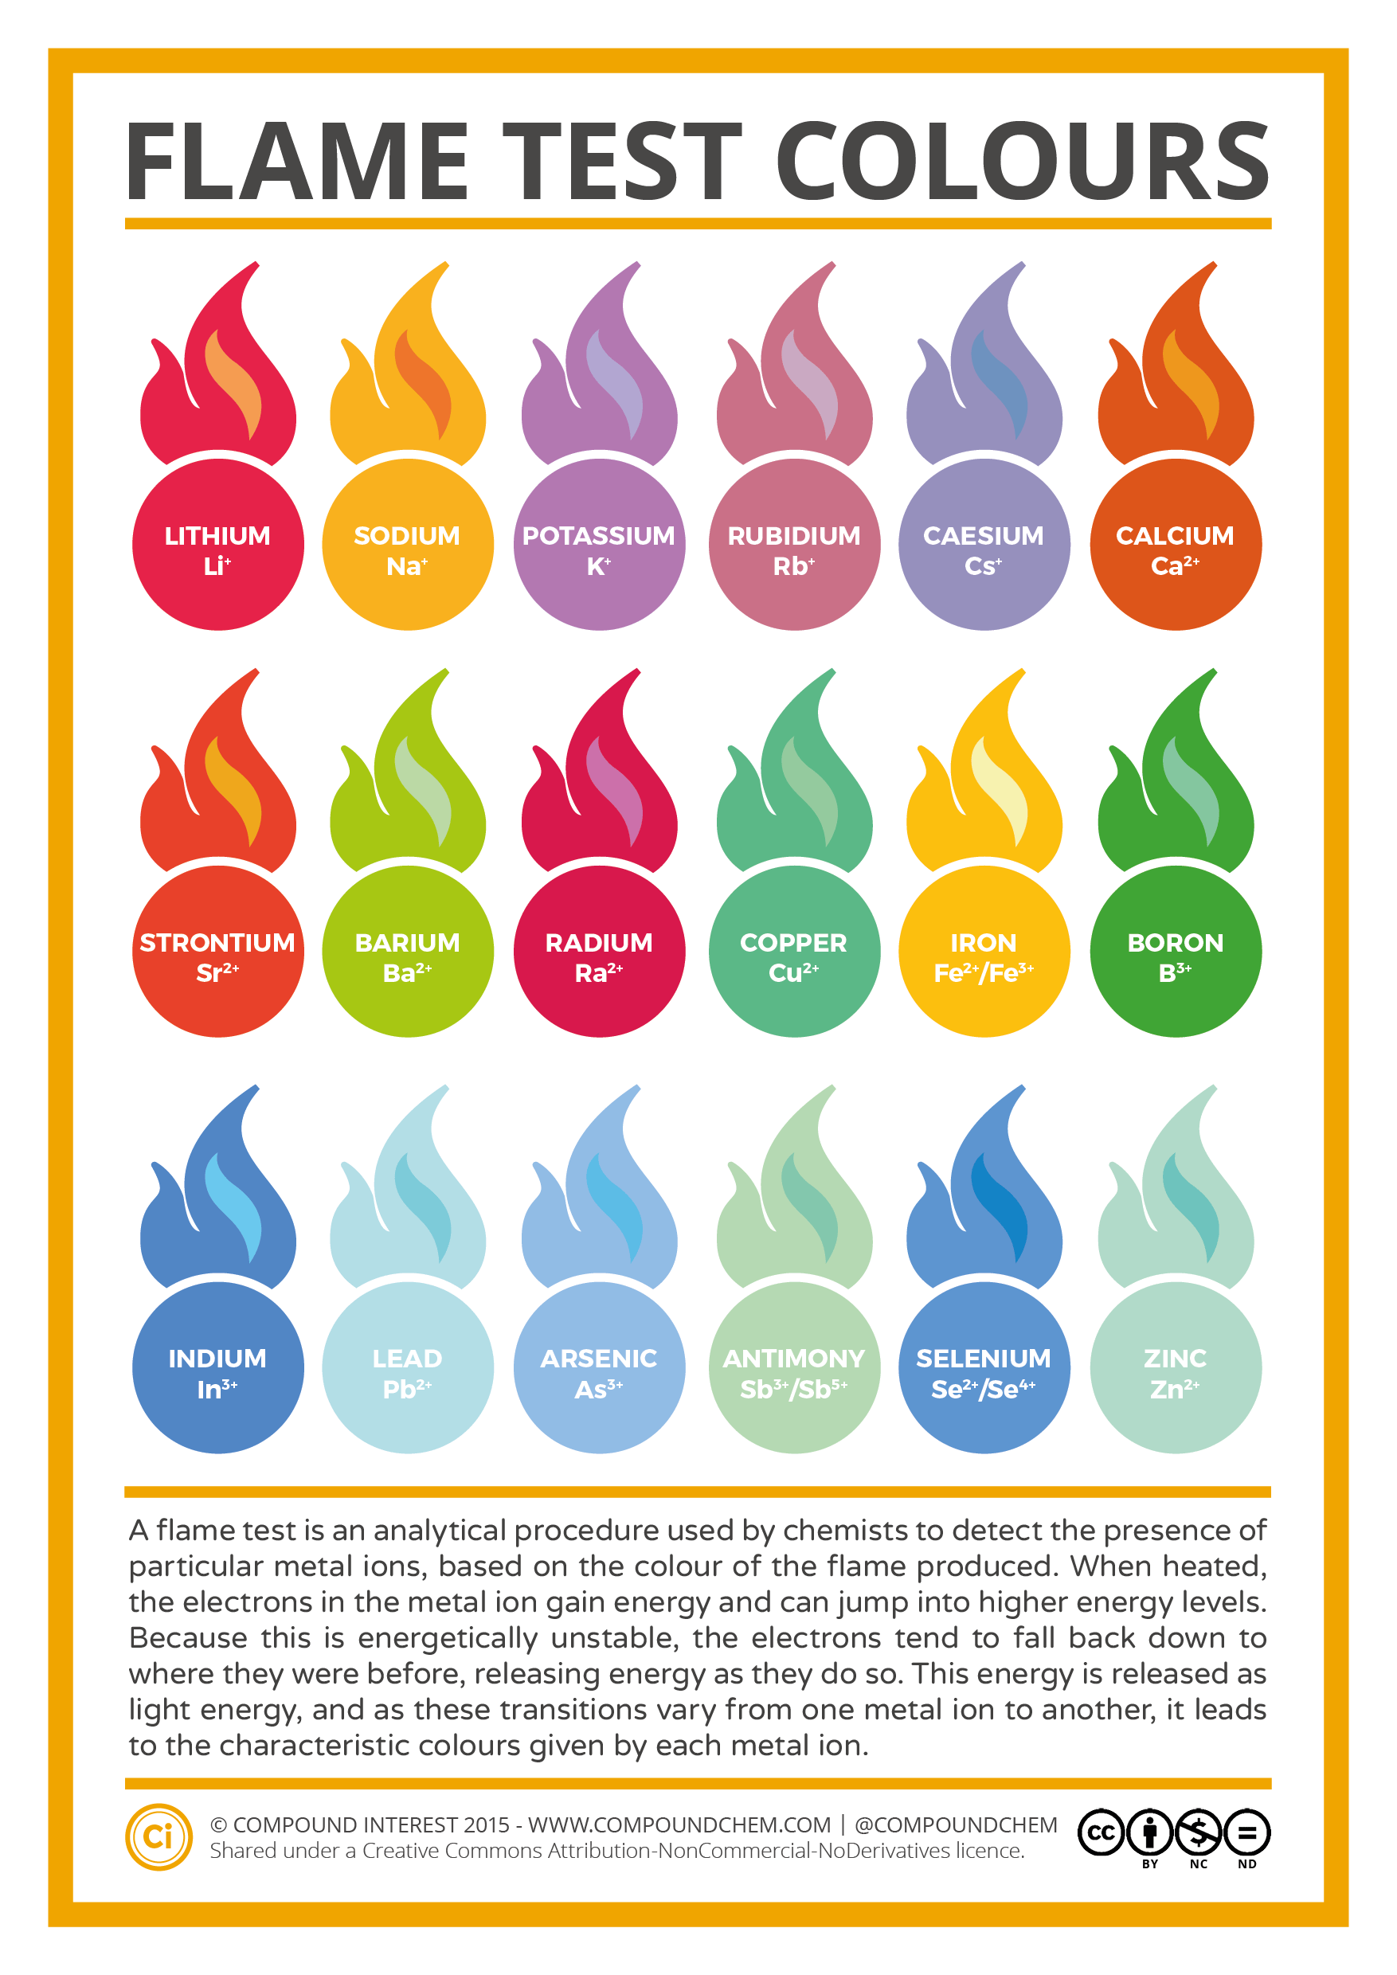

ATOMIC ABSORPTION SPECTROSCOPY (AAS)

* A quantitative form of analysis, can determine the amount of an element present in a sample of a substance
* A hollow cathode lamp, made of the same element we want to test for, is constructed
* When an electric current passes through the lamp, it emits light
* The light travels through a vaporised sample that is being tested
* Only the element being tested for will absorb light from the lamp
  + Because the energy levels in the emitted light will be the same as the element present in the sample
* A detector measures the intensity of light which is displayed as an absorbance number
  + e.g. 40% of the light passed through without being absorbed
* this number can be used to determine concentration by using something called a calibration curve

# BONDING

Atoms bond to reach the most stable energy state

* They can achieve this by gaining a stable electron configuration
* ∴ they ‘want’ to achieve noble gas electron configuration
  + This is based on their valence shell having 8 electrons – the octet rule (or having 2 valence electrons like helium)
* Atoms can get noble gas configuration by:
  + Sharing electrons or
  + Taking or losing electrons (electron transfer)

IONIC BONDING:

* Between a metal and a non-metal

METALLIC BONDING:

* Between metals

COVALENT BONDING:

* Between non-metals

# *IONIC COMPOUNDS + IONIC BONDING

WHY DO IONS FORM?

* Atoms can achieve noble gas electron configuration by losing or gaining electrons
* This will mean the atom becomes a charged particle called an ion

CATIONS AND ANIONS

* Metals generally contain 1-4 valence electrons, and have relatively low electronegativity and low 1st ionisation energy
* Therefore valence electrons are weakly held and can be removed easily
* Metals will generally form a positive ion (a cation) to gain noble gas configuration
* Non-metals contain 4-8 valence electrons and have relatively higher electronegativity and higher ionisation energy
* Some non-metal atoms will gain the extra electrons needed to gain noble gas configuration and become a negative ion (an anion)

IONS AND THE PERIODIC TABLE

* Group 1 and 2 metals (and hydrogen – a non-metal) tend to form cations with a charge of +1 and +2 respectively
* Transition metals (groups 3-12) can sometimes form more than one cation (always positive because they are metals), each with a different charge. E.g copper can form an ion with a charge of +1 or +2
* When naming ions from transition metals, the charge will be in brackets with Roman numerals
  + E.g Copper (I) and Copper (II)
* The only transition metals that always form one particular ion are Silver (+1), Zinc (+2) and Cadmium (+2)
* Aluminium and Gallium in group 13 will form cations with a charge of +3
* Non-metals in group 15, 16 and 17 tend to form anions with a charge of -3, -2 and -1 respectively

HOW IONIC COMPOUNDS FORM

* When a metal and a non-metal bond, they form an ionic compound
* The non-metal has a much higher electronegativity than the metal
  + This means that it attracts the electrons more
* Therefore it takes electron(s) from the metal
* This will result in the formation of cations and anions
* When the cation(s) and anion(s) have formed, the opposite charges attract and form an ionic bond
* This is a strong electrostatic attraction, and is 3-dimensional (each cation attracts an anion in all directions and vice versa)
* When ionic bonds form, the new compound is called an ionic compound
* An ionic compound has a crystal lattice structure

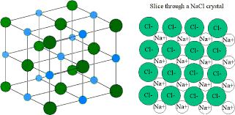

POLYATOMIC IONS

* Ions that are formed from a single atom are called monatomic ions
* Ions that are formed from 2 or more atoms are called polyatomic ions
* In some cases the anion or cation may be a polyatomic ion
  + These are ions that are made up of more than one atom
    - E.g hydroxide (OH-) or ammonium (NH4+)

STRUCTURE OF IONIC COMPOUNDS

* In a solid state, an ionic compound consists of the ions held in an orderly 3 dimensional lattice
* The electrostatic attraction between the cations and anions occurs in all directions
* A negative ion will attract positive ions in all directions and vice versa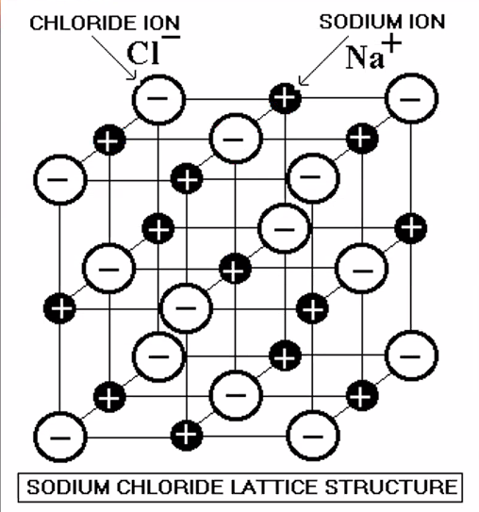

PROPERTIES OF IONIC COMPOUNDS

1. Ionic compounds are hard and brittle
   * The strong electrostatic attraction holds the ions together firmly, therefore it is hard
   * If any part of the lattice is disrupted it causes like charges to come closer together and repel each other, which causes the crystal to shatter, therefore it is brittle

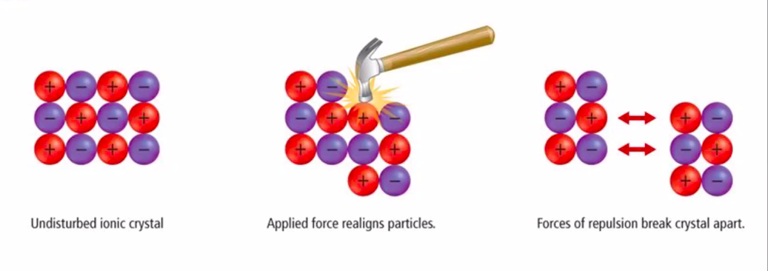

1. Ionic compounds have high melting and boiling points
   * The attractive forces between the ions is very strong
   * A lot of energy is required to overcome the force, therefore a high temperature is needed to break the bonds and form a liquid or gas
2. Ionic compounds conduct electricity when molten or dissolved in a solution.
   * For a substance to conduct electricity there must be charged particles that are able to move freely to carry the electric current.
   * In a solid state, the ions are in a fixed position and therefore cannot conduct electricity. (because they can’t move freely)
   * When the compound is melted or in an aqueous state, the ions are able to move freely and therefore are able to conduct electricity.

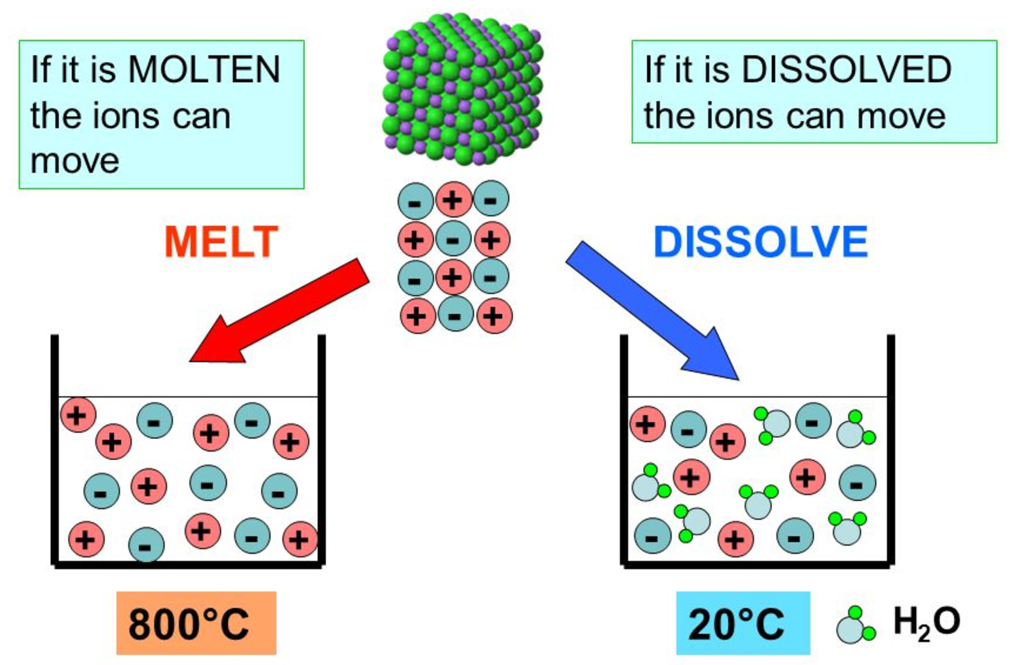

# METALLIC BONDING

* The bonding between the atoms of a metal
* Metal atoms have a low electronegativity and ionisation energy
* This means that it takes only a small amount of energy to remove the outermost electrons
* Metal atoms will lose their valence electrons and form a cation
* The electrons that have been lost from each atom are delocalised
* This means that they are not restricted to one atom or ion but move in between them
  + i.e. in a piece of metal, the electrons are freely moving between the atoms within that piece of metal

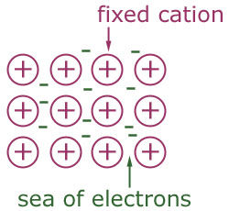

* a metallic bond is the electrostatic attraction between the cations and the ‘sea’ of delocalised electrons (negative)
* metallic bonds are generally very strong, the strength depends on:
  + the number of delocalised electrons, therefore the charge of the cation
  + the size of the cation, therefore the number of protons and inner electrons
  + how closely packed the cations are

STRUCTURE OF METALS

* A metal is made up of a lattice of cations with a sea of delocalised electrons

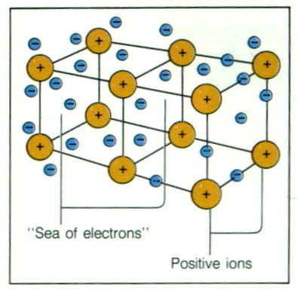

PROPERTIES OF METALS

1. High melting and boiling point
   * The metallic bond is very strong
   * Therefore it takes a lot of energy to overcome the attraction to allow the cations to move more freely
   * Therefore a high temperature is required to provide that amount of energy
2. Hardness
   * The metallic bond is very strong and therefore requires a lot of energy to overcome
   * Therefore metals are generally hard
3. Conduct electricity in all states
   * The delocalised electrons are able to move freely between the cations
   * Therefore they are able to carry a current
4. Conduct heat (thermal conductivity)
   * The free moving delocalised electrons are able to transfer heat energy
5. Malleable and ductile
   * Malleable: able to be hammered into sheets
   * Ductile: able to be drawn into wires
   * As the metallic bond is non-directional, the cations are able to be moved without disrupting the strength of the bond
   * i.e. the layers of metal cations are still held together by the delocalised electrons between them

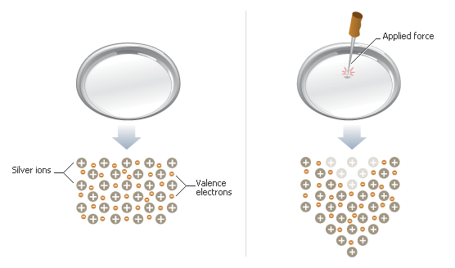

1. Lustre
   * Lustre: soft, shiny light reflected from the surface
   * The delocalised electrons are moving and reflect the light
2. Poor solubility
   * The metallic bond is very strong and is not able to be broken by the solvent

# *COVALENT BONDING

* When atoms have a similar electronegativity, neither is ‘strong’ enough to take the other’s electrons
  + Therefore they share electrons to gain noble gas configuration
* This type of bond occurs between non-metals
* A covalent bond is the electrostatic attraction between the positive nuclei and shared pairs of electrons of atoms involved

* Covalent bonds are directional – there is a direct ‘line’ between the bonding atoms
* The number of valence electrons in the atoms determines the number of covalent bonds that it needs to form in order to gain the electron configuration of a noble gas
  + Group 17 non-metals (and hydrogen) need to form 1 covalent bond
  + Group 16 non-metals need to form 2 covalent bonds
  + Group 15 non-metals need to form 3 covalent bonds
  + Group 14 non-metals and metalloids (carbon and silicon) need to form 4 covalent bonds
* If more than one covalent bond is needed (i.e. the atom needs more than one more electron) then the atom may achieve this by forming a double or triple bond, or bonding with numerous atoms
* If 2 electrons are shared it is called a single covalent bond
* If 4 electrons are shared it is a double covalent bond
* If 6 electrons are shared it is a triple covalent bond
* Covalent bonds are very strong, and require a large amount of energy to be broken
* Covalent bonds occur in covalent molecular substances and covalent network substances

COVALENT MOLECULAR SUBSTANCES

* Most substances formed from non-metals will becovalent molecules(2 or more atoms joined by a covalent bond) where there are a set number of atoms within a defined structure
  + These can be molecules of an element – e.g. O2 **or** molecules of a compound – e.g. CO2

LEWIS DIAGRAMS (ELECTRON DOT DIAGRAMS)

Lewis symbols

* Shows the symbol of the element with dots or crosses to represent the valence electrons

① ELEMENTS

Lithium

Oxygen

② MONATOMIC IONS

^ a cation

^ an anion

③ IONIC COMPOUNDS INVOLVING MONATOMIC IONS

LEWIS STRUCTURES

* Shows the bonding of atoms in covalent molecules and polyatomic ions

① MOLECULES OF AN ELEMENT

② MOLECULES OF A COMPOUND

③ POLYATOMIC IONS

COORDINATE COVALENT BONDS

* A covalent bond in which both electrons in the shared pair come from the same atom

DIAGRAMS from the onenote-----

STRUCTURE AND PROPERTIES OF COVALENT MOLECULES

* The covalent bonds between the atoms of a molecule are strong
* The bonds between the molecules are called intermolecular forces. These are much weaker than covalent bonds

Low melting and boiling point

* The intermolecular forces are relatively weak and therefore do not require much energy to be broken
* Therefore a low temperature provides enough energy to melt or boil the substance
* Many covalent molecular substances are gases at room temperature

Non-conductor of electricity

* In a covalent molecule the electrons are localised to particular atoms
* There are also no ions present in the pure form
* Therefore there are no charged particles that are able to move to conduct a current
* Some covalent molecules are able to ionise when they dissolve. These would then be able to conduct electricity

Soft

* The weak intermolecular forces mean that the molecules are easily displaced
* This means that covalent molecular substances are soft

COVALENT NETWORK SUBSTANCES

* Some substances that are formed from covalent bonding do not form discrete molecules
* They form a network with a growing 3-dimensional structure of covalent bonds
  + Eg. Diamond is made up of a network of carbon

PROPERTIES OF COVALENT NETWORKS

High melting and boiling point

* The strong covalent bonds require a large amount of energy to be broken
* Therefore a very high temperature is needed to provide enough energy

Extremely hard and brittle

* The strong covalent bonds are hard to break
* However if some are broken the rest are placed under stress and the network shatters

Non-conductors as solids or liquids

* The electrons are all localised within bonds or atoms
* Therefore there are no-free moving charged particles to conduct electricity
  + Graphite is an exception. It has covalent bonds in 2 dimensions forming 3 covalent bonds each. The remaining electron is delocalised and provides the bond between the layers. These delocalised electrons are able to carry a current.

# *ORGANIC CHEMISTRY

ORGANIC COMPOUNDS

* Organic compounds are those containing carbon (with some exceptions: including carbon dioxide and carbonate)
* Because carbon has 4 valence electrons it can form up to 4 single covalent bonds, or form double and triple bonds
* It can form chains or loops with itself and can bond to other elements including hydrogen, oxygen, nitrogen, sulfur and the halogens
* Because of the range of possibilities of bonding, there are many, many, many different arrangements and therefore molecules

## HYDROCARBONS

* A hydrocarbon is a molecule composed only of carbon and hydrogen
* They can form chains and loops of various lengths
* The carbons bond to each other and the hydrogen atoms bond to the carbon atoms

TYPES OF HYDROCARBONS

* Hydrocarbons can be classified based on whether they have single, double or triple bonds between the carbons
* Alkanes are hydrocarbons with only singles bonds between the carbon atoms

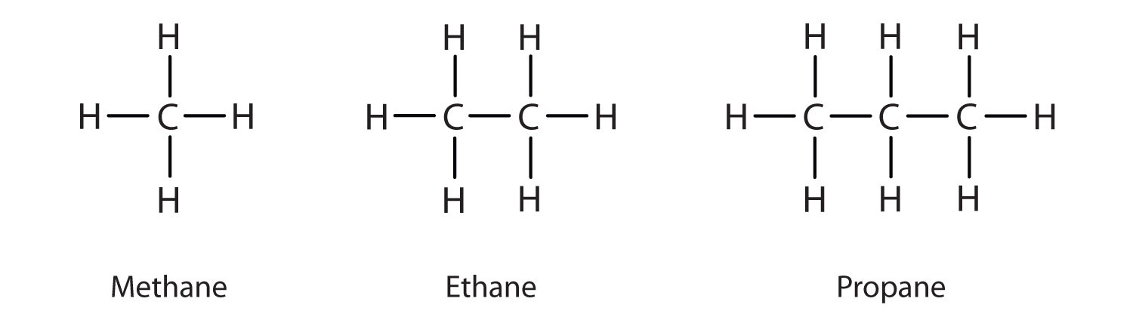

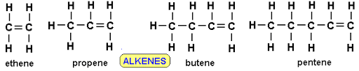

* Alkenes are hydrocarbons with one or more double bonds between the carbon atoms
* Alkynes are hydrocarbons with one or more triple bond between the carbon atoms
  + (we don’t cover this in year 11 chem but it is interesting to note)

## ALKANES

* Alkanes are saturated hydrocarbons because each carbon atom has as many hydrogen atoms as possible bonded to it (because of the single bonds)
* The general molecular formula for alkanes is
$C_{n}H_{2n+2}$

* This is because each carbon atom has 2 hydrogen atoms attached, plus the carbons at the end have an extra hydrogen.
* The stem name (the prefix) tells you the number of carbons in the longest chain

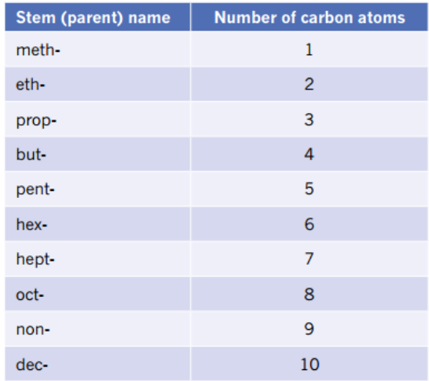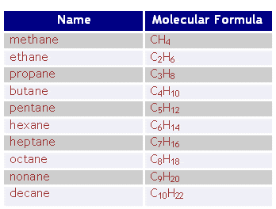

* Structural formula shows each bond with a line or a condensed structural formula can be used to show each carbon atom and its attached hydrogen atom

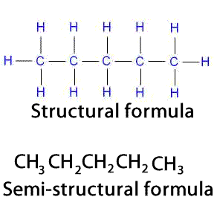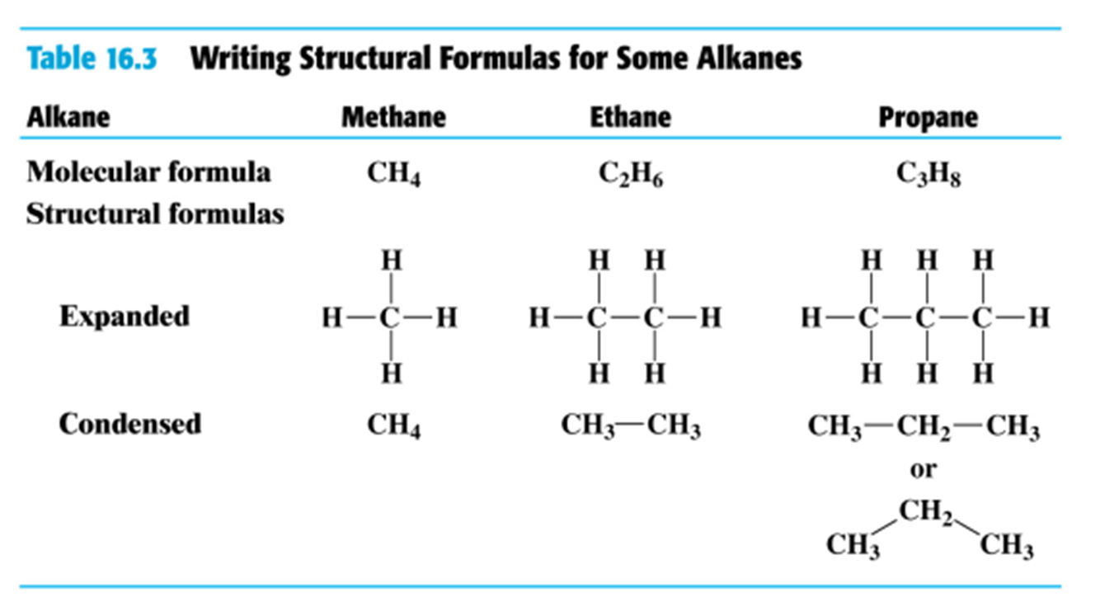

* Alkanes can form straight chains or branched structures (+ ‘circle structure’)
* The groups added to the main chain of carbon that form the branches of an alkane are called substituent groups
* Substituents can be alkyl groups – containing carbon and hydrogen and named by dropping the ‘ane’ of an alkane and replacing it with ‘yl’.
  + E.g. methane (CH4) vs methyl group (CH3) or ethane (C2H6) vs ethyl group (C2H5)
* Substituents can also be halogens – named by changing the end of the element to ‘o’.
  + E.g. chloro or bromo

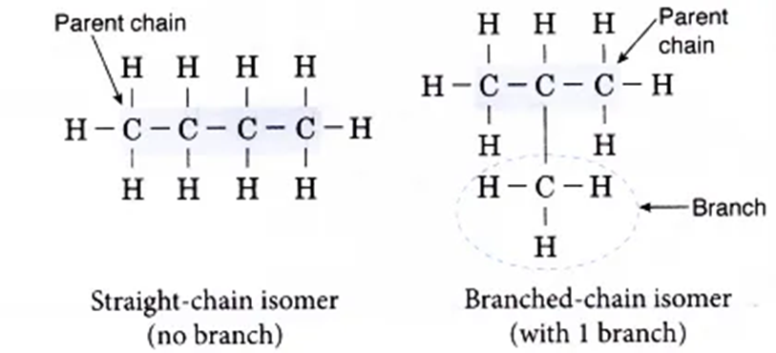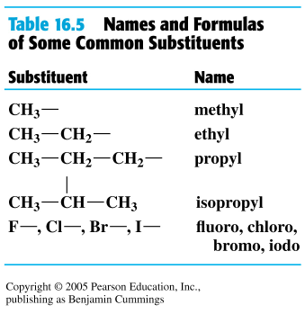

^ diagram on the right is 2-methylpropane (the methyl substituent is coming from the 2nd Carbon in the parent chain, hence the 2)

STRUCTURAL ISOMERS

* Have the same molecular formula but a different structural formula
* Methane, ethane and propane do not have isomers, but past that point other alkanes do

Note: The substituent group allows you to name the isomer

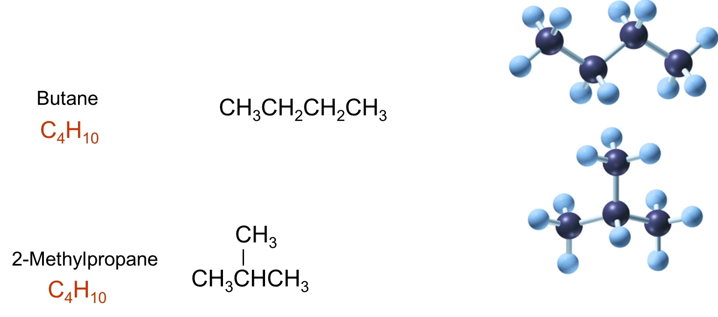

## NAMING ALKANES

STEPS FOR NAMING ALKANES

1. Find the longest chain
2. Number the carbons, starting at the end closest to the substituent groups. If there is more than 1 substituent, the sum of the numbers needs to be the lowest
3. For each substituent group write the number of the carbon it is bonded to followed by its name. Name each substituent group in alphabetical order.
4. If there are more than one of a particular substituent group, write both numbers (separated by a comma) then use the prefix di, tri, tetra, penta etc. to show how many there are
5. Then write the name of the main chain, using the prefix meth, eth etc. followed by the suffix ‘ane’.
6. Separate numbers with a comma and separate a number and a word with a dash.

NAMING ALKANES

CYLIC HYDROCARBONS – CYCLOALKANES

Cyclobutane:

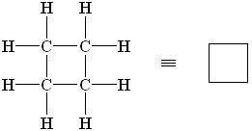

Cyclopentane

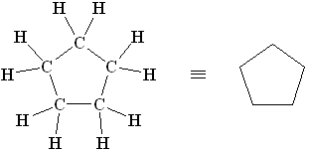

Cyclohexane

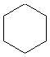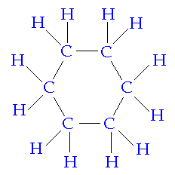

=

PHYSICAL PROPERTIES OF ALKANES

* MP and BP – Alkanes (and other hydrocarbons) in general have a low melting point and boiling point
  + This is because they are covalent compounds with weak forces between the molecules which require little energy to disrupt
  + As the length of the chain increases, the strength of the forces between the molecules also increases
    - This means that the amount of energy to disrupt these bonds increases and so the melting point and boiling point increases
  + Therefore alkanes with 1 – 4 carbons are gases at room temperature, those with 5 – 17 are liquids and those with more than 17 carbons are solids at room temperature

Solubility

* As alkanes are non-polar substances (more on this later-----), they are not soluble in water.

Conductivity

* There are no charged particles free to move in alkanes, therefore they do not conduct electricity
  + All the electrons are localised in the bonds (the sharing of the electrons) so none of them are delocalised

## REACTIONS OF ALKANES (CHEMICAL PROPERTIES)

* Alkanes will undergo combustion reactions – a reaction with oxygen that releases energy (an exothermic reaction)
  + This requires ignition and will produce carbon dioxide, water and heat.
    - E.g. The combustion of propane:
    - C3H8(g)
    - DIAGRAM FROM EXAMPLE IN CLASS-----
* Alkanes also undergo substitution reactions
  + In these reactions a hydrogen atom is substituted with an atom of a different element, often a halogen.
  + This typically requires ultraviolet light as a catalyst
  + When reacting with a halogen; the halogen molecule will split and the bond between the carbon and hydrogen will break.
  + One atom of the halogen will bond to the carbon and the other will bond with the spare hydrogen atom.
  + The amount of the halogen present will determine how many hydrogen atoms are substituted.
  + If there is an excess of the halogen (excess reactant) then there will be more substitutions
    - E.g. The reaction between chlorine and methane
    - DIAGRAM FROM EXAMPLE IN CLASS-----

## ALKENES

* Alkenes are hydrocarbons that contain at least one double bond between carbon atoms
* They are called unsaturated hydrocarbons as they are able to fit more hydrogen atoms onto the molecule
* Alkenes have the general formula CnH2n
  + DIAGRAM FROM EXAMPLE IN CLASS-----



## NAMING ALKENES

* Alkenes are named very similarly to alkanes.
* The only difference is that the presence and location of the double bond must be identified
* We number the carbons so that the double bond has the lowest number.
* The number of the lowest carbon that is involved in the double bond is written in the name to identify its location
* This is written before the ‘ene’ or sometimes before the main chain name.
  + Eg. but-2-ene or 2-butene
  + 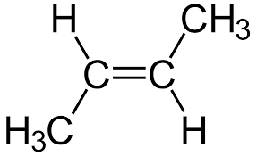
* If there is more than 1 double bond, the location of each is identified with its number and the prefix di, tri etc is written in front of the ‘ene’.
  + Eg. Buta-1,2-diene
  + 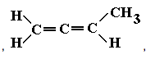
    - This hasn’t really been shown in any exams supposedly for Y11

## REACTIONS OF ALKENES

* Because of the double bond, and the fact they are unsaturated, alkenes are generally more reactive than alkanes
* Alkenes will undergo combustion, reacting with oxygen, producing carbon dioxide and water.
  + E.g. combustion reaction with ethene:
  + C2H4(g) + 3O2(g) 🡪 2CO2(g) + 2H2O(g) + heat
* This type of reaction can make an unsaturated compound become saturated (‘turn an alkene into an alkane’)
* They also undergo addition reactions where one of the bonds in the double bond breaks and an atom is added to each of the carbons involved.
* Addition reactions can involve:
  + Halogens
  + Hydrogen
  + Hydrogen halides (HCl, HBr, HF, HI)
  + Water
    - E.g. reaction with chlorine (Cl2)
    - DIAGRAM FROM EXAMPLE IN CLASS-----

# FORMULA AND MOLECULAR MASS

* Using the relative atomic mass of elements from the periodic table, you can calculate relative molecular mass or relative formula mass for:
  + Molecules of an element
  + Molecules of a compound
  + Ionic compounds – formula mass
* The symbol for formula/molecular mass is Mr

EXAMPLES

① sulfuric acid

H2SO4

Mr(H2SO4) =

(4s.f)

② magnesium hydroxide

(Mg(OH)2)

Mr(Mg(OH)2) =

(4s.f)

# THE MOLE AND NUMBER OF PARTICLES

* The mole is a quantity used to describe the amount of a substance
* It is based on the number of particles of carbon found in 12 grams of Carbon-12
* This has been determined as approximately $6.022×{10}^{23}$ particles
  + This is Avogadro’s number (NA)
* ∴ 1 mole of anything is ≈ $6.022×{10}^{23}$ particles of that thing
* The symbol for moles is ‘n’, and the unit is mol.
  + E.g 1 mol of H2O = H2O particles
  + 1 mol of Au atoms = $6.022×{10}^{23}$ Au atoms
* We can use number of moles and Avogadro’s number to determine the number of particles for atoms, molecules and compounds and vice versa

EXAMPLES

① find the number of water molecules in 2.3 mol of water

N(H2O) = 2.3 mol

NA=

N(H2O)=?

N=

② find the number of hydrogen atoms in 0.35 mol of methane

n(CH4) = 0.35mol

n(H) = $4×0.35$

$$=1.4 mol$$

NA=

N(H) = ?

N(H) = $1.4×6.022×{10}^{23}$

$$=8.43×{10}^{23}$$

$$=8.4×{10}^{23}$$

# MOLAR MASS AND PERCENTAGE COMPOSITION

* The particles of different elements and compounds have a different actual mass (in grams)
  + ∴ 1 mol of gold atoms will have a different mass to 1 mol of hydrogen atoms
* The mass (in grams) of 1 mol of an element or compound is called molar mass (M)
* Molar mass is the same value as the relative atomic mass/relative formula mass/relative molecular mass of a given element/compound, but the units are grams per mole (gmol-1 or g/mol)

EXAMPLES

① molar mass oxygen gas (O2)

M(O2)

gmol-1

Look on the P.T for the number (the 16) then multiply it by the amount (in this case it is the 2)

∴ there are 32 grams of oxygen gas per mole of it

* Percentage composition tells you the proportion by mass of the different elements in a compound

$$\% mass of element= \frac{mass of given element in 1 mol of compound}{molar mass of compound}×100$$

*molar mass will work the same for molecular/formula mass

EXAMPLE

Calculate % by mass of each element in magnesium chloride (MgCl2)

M(Mg) = 24.31

M(Cl) = 35.45

M(MgCl2) = 24.31 + ()

%(Mg) = $\frac{24.31}{95.21}×100$

$$=25.53\%$$

%(Cl) = $\frac{2×35.45}{95.21}×100$

$$=74.47\%$$

# MOLAR MASS, MASS AND MOLECULES

* The relationship between moles (n), molar mass (M) and given mass (m) of a substance is summarised as:

$$n=\frac{m}{M}$$

(on the data sheet)

m = in grams

M = in gmol-1

FLOW CHART OF mg 🡪 grams 🡪 kg 🡪 tonnes

* The applications of this formula are numerous, the best way to learn is through practice

EXAMPLES

1. Calculate the mass of 3.2 mol of copper(I) nitrate (CuNO3)

N(CuNO3) = 3.2 mol

M(CuNO3) =

= 125.55gmol-1

m(CuNO3)=?

1. Calculate the number of oxygen atoms in 5.6g of silica (SiO2)

Step 1: calculate the number of mols of what you’ve been given

n(SiO2) = in 5.6g of silica

Step 2: find the number of moles (using ratio) for what’s being asked

n(O) = $2×n(SiO_{2})$

$$=2×0.09$$

$=0.18mol$ of oxygen in 5.6g of silica

Step 3: answer the question (find the number of atoms)

N(O) = n(O) $×$ NA

NA means use avogadros number

$$=0.18×6.02×{10}^{23}$$

# STOICHIOMETRY

* calculations using balanced chemical equations
* using ratios in equations to do calculations

# MISC NOTES – REACTIONS OF HYDROCARBONS

ORGANIC COMPOUNDS - ALKANES

* alkanes are saturated hydrocarbons because each carbon atom has as many hydrogen atoms as possible bonded to it (because of the single bonds)
* the general molecular formula for alkanes is CnH2n+2
* this is because each carbon atom has 2 hydrogen atoms attached, plus the carbons at the end have an extra hydrogen
* substitution/combustion
* alkanes will undergo combustion reactions – a reaction with oxygen that releases energy (an exothermic reaction)
* this requires ignition and will produce carbon dioxide, water and heat
* e.g. The combustion of propane: C3H8 (g) + 5O2 (g) —> 3CO2 (g) + 4H2O(g) + heat
* complete combustion has carbon dioxide (above) - if less oxygen present product will be carbon monoxide (this would be incomplete combustion)
* alkanes also undergo substitution reactions
* in these reactions a hydrogen atom is substituted with an atom of a different element, often a halogen
  + this typically requires ultraviolet light as a catalyst
* when reacting with a halogen; the halogen molecule will split and the bond between the carbon and hydrogen will break
* one atom of the halogen will bond to the carbon and the other will bond with the spare hydrogen atom
* the amount of the halogen present will determine how many hydrogen atoms are substituted
* if there is an excess of the halogen (excess reactant) then there will be more substitutions
* e.g. The reaction between chlorine and methane:

ORGANIC COMPOUNDS - ALKENES

* alkenes are hydrocarbons that contain at least one double bond between carbon atoms
* they are called unsaturated hydrocarbons as they are able to fit more hydrogen atoms onto the molecule
* alkenes have the general formula CnH2n  (see book for three different formulas)
* form combustion/addition

REACTIONS OF ALKENES

* alkenes will undergo combustion, reacting with oxygen, producing carbon dioxide and water
* e.g. combustion reaction with ethene: C2H4(g) + 3O2 (g) —> 2CO2 (g) + 2H2O(g) + heat
* they also undergo addition reactionswhere one of the bonds in the double bond breaks and an atom is added to each of the carbons involved
  + because of the double bond, and the fact they are unsaturated, alkenes are generally more reactive than alkanes
  + this type of reaction can make an unsaturated compound become saturated ('\turn an alkene into an alkane)
* addition reactions can involve:
  + Halogens
  + Hydrogen
  + Hydrogen halides (HCl, HBr, HF, HI)
  + Water
* e.g. reaction with chlorine (can be a test for saturation) (see book for drawings)

ORGANIC COMPOUNDS - BENZENE

* compounds which contain one or more benzene rings are called aromatic compounds as they have a pleasant odour
* combustion or substitution

# ENERGY AND CHEMICAL REACTIONS

CHEMICAL ENERGY

* chemical energy is stored in the bonds of a chemical
* the SI unit for energy is Joules (J). Other units include kilojoules (kJ) and megajoules (MJ)

ENTHALPY

* enthalpy is the sum of the internal energy and the product of pressure and volume
* enthalpy can sometimes (more simply) just refer to the chemical energy or heat content of a substance
* enthalpy is given by the symbol of H and is measured in kJ/mol

CHEMICAL SYSTEMS AND SURROUNDINGS

* when talking about energy changes in chemical reactions we refer to systems and surroundings in chemistry
* the system is the chemicals directly involved in a reaction
* everything else is the surroundings
* in a chemical reaction, energy leaves the system and enters the surroundings, or vice versa

ENERGY CHANGES DURING CHEMICAL REACTIONS

* chemical reactions involve breaking the bonds between atoms, rearranging the atoms and then making new bonds

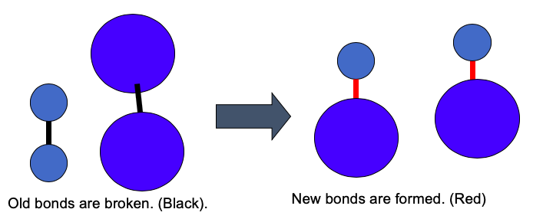

* to break the bonds in the reactants energy is absorbed
* breaking bonds requires energy

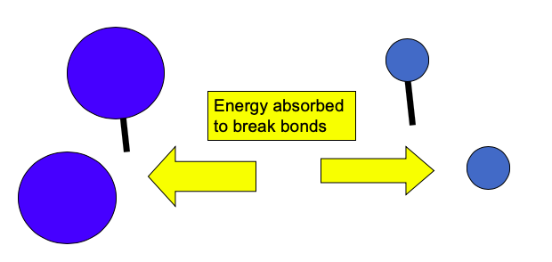

* the energy absorbed by the reactants to break the bonds (to get the reaction started) is called activation energy
* when the bonds are broken, the particles that are separated have a lot of energy (or enthalpy)
* this is sometimes called the transition state or activated complexand is very unstable
* therefore energy is released as new bonds in the products form.
* making bonds releases energy

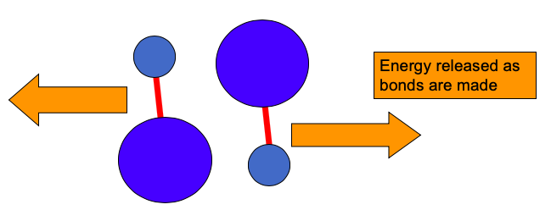

* the law of conservation of energy states that energy cannot be created or destroyed
  + therefore the energy in a chemical reaction is either absorbed from, or released into the surroundings
* the change in energy in a chemical reaction is often referred to as a change in enthalpy (or heat of reaction)
* The change in enthalpy is shown as ∆H
* The change in enthalpy is the enthalpy of the products minus the enthalpy of the reactants

∆*H* = *H*products - *H*reactants

EXOTHERMIC AND ENDOTHERMIC REACTIONS

* if the amount of energy stored in the reactants is greater than the energy stored in the products the excess energy is released
  + the energy released when bonds form is greater than the energy used to break bonds
  + therefore there is a net release of energy
  + this is called an exothermic reaction
  + because the energy in the system is ‘lost’ to the surroundings, the enthalpy change is a negative value (∆*H* < 0)
  + if the energy released in an exothermic reaction is thermal energy, then the surroundings will increase in temperature

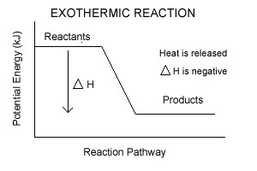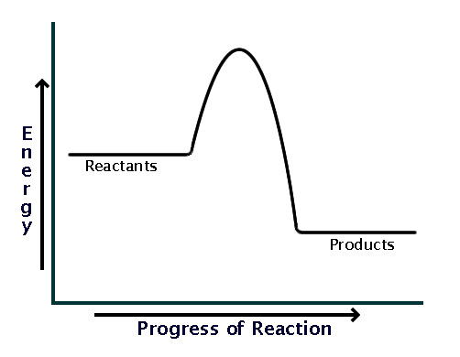

* if the amount of energy stored in the reactants is less than the energy stored in the products then energy needs to be absorbed from the surroundings
  + the energy used to break bonds is greater than energy released when bonds form
  + therefore there is a net absorption of energy
  + this is called an endothermic reaction
  + because the system gains energy from the surroundings the enthalpy change is a positive value (∆*H* > 0)
  + the thermal energy that is absorbed will cool the surroundings, decreasing their temperature

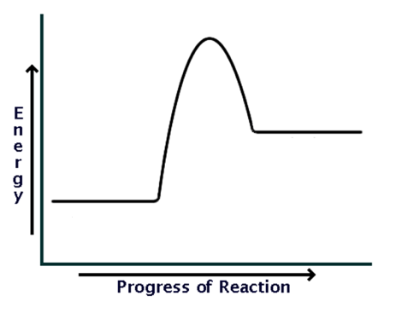

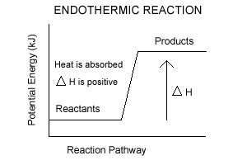

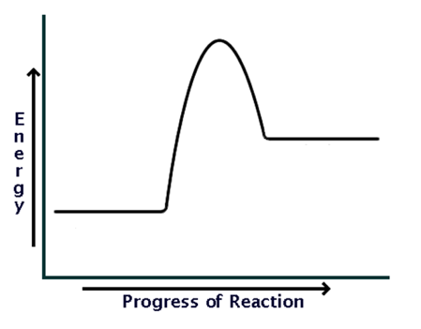

CHANGES OF STATE (PHASE CHANGES)

* phase changes are physical changes (not chemical reactions) but still involve energy being absorbed or released
* e.g. melting ice to water requires absorption of energy, therefore is endothermic

this is summarised by:

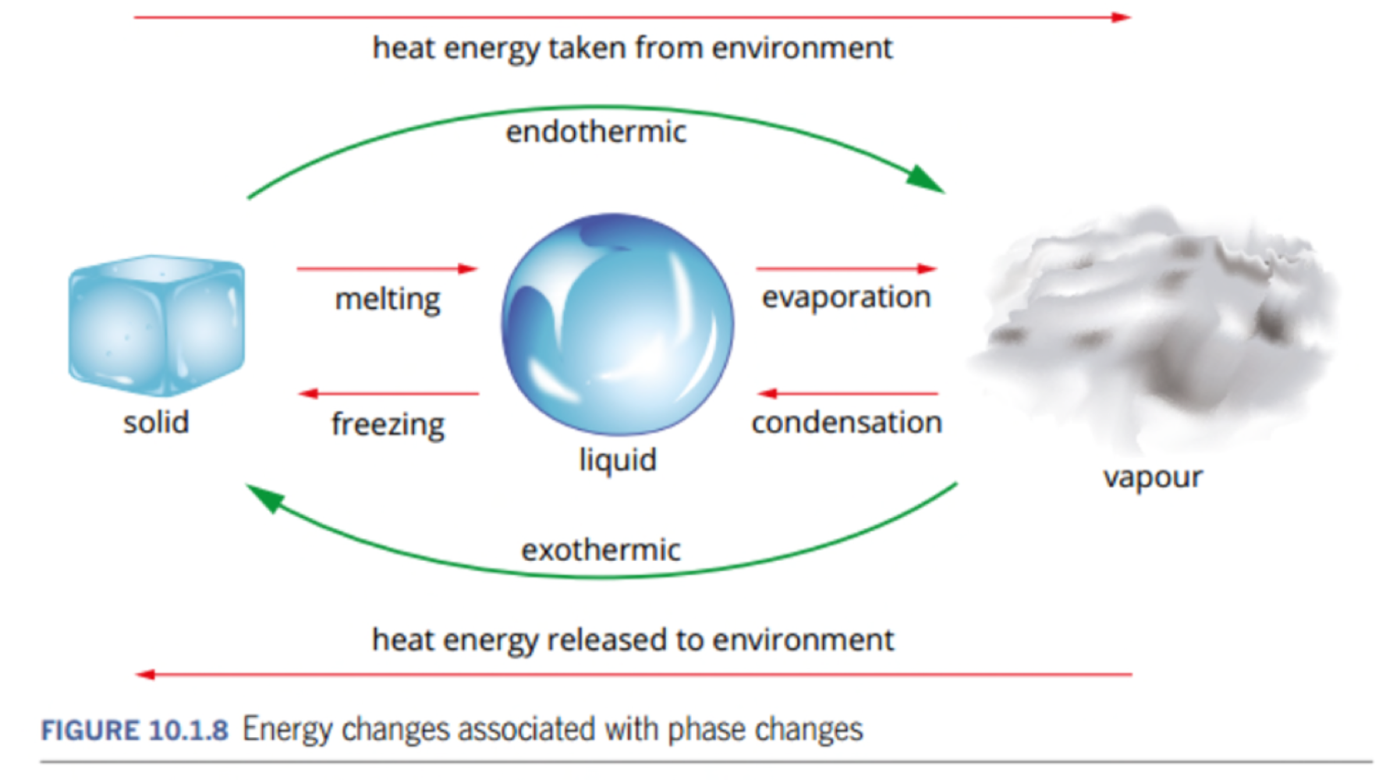

THERMOCHEMICAL EQUATIONS

The energy released or absorbed in a chemical reaction may be written in the chemical equation

* In an exothermic reaction it is written as a product
* In an endothermic reaction it is written as a reactant
* The energy may be written as:
  + The amount of energy in kJ
  + The type of energy e.g heat, light
  + Simply as ‘energy’
* For example:
  + 6CO2 + 6H2O + energy 🡪 C6H12O6 + 6O2
    - An endothermic reaction
  + 2Mg + O2 🡪 2MgO + energy
    - An exothermic reaction
* Alternatively the heat of reaction may be written after the equation.
  + For example:
    - H2(g) + F2(g) 🡪 2 HF     ∆*H* = -542 kJ
  + This can also be shown in phase changes (physical changes)
    - H2O(s) 🡪 H2O (l) ∆*H* = +6 kJ

REARRANGING THERMOCHEMICAL EQUATIONS

H2 + F2(g) 🡪 2HF(g) H=-542kJ

= H2 + F2(g) + 542kJ 🡪 2HF(g)

endothermic ∴ on reactant’s side

H2O(s) 🡪 H2O(l) H=+6kJ

= H2O(s) 🡪 H2O(l) + 6kJ

exothermic ∴ on product’s side

ENERGY PROFILE DIAGRAMS

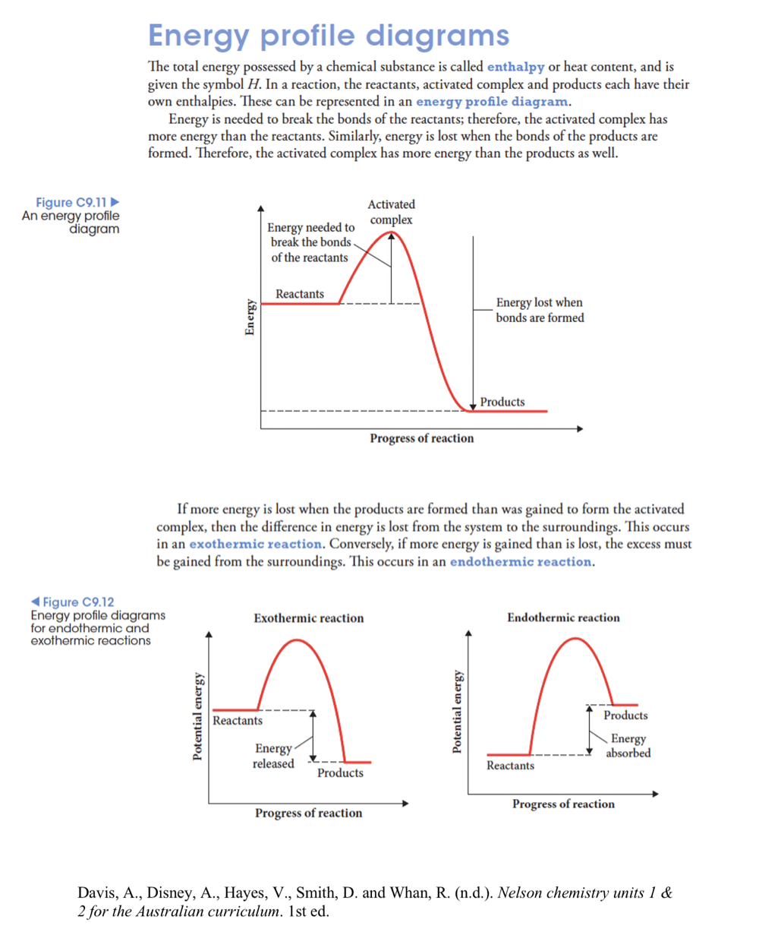

# FUELS

(Pearson Textbook – Chapter 11)

* a substance that releases energy

FOSSIL FUELS

* made from ancient plants, animals and microorganisms that have undergone complex chemical changes
* form over millions of years therefore they are non-renewable
* e.g. coal, oil, petroleum and natural gas

BIOFUELS

* created from living or recently dead biological material (biomass)
* such as grains, sugar cane, vegetable waste and vegetable oils
* renewable - can be constantly replenished
* e. g. biogas, bioethanol, biodiesel

COMBUSTION OF FUELS

* both fossil fuels and biofuels undergo combustion reactions
  + exothermic reactions with oxygen
* fossil fuels and biofuels contain carbon and hydrogen (hydrocarbons)
  + products released from complete combustion will be carbon dioxide gas and water (vapour)
  + incomplete combustion produces carbon monoxide and/or carbon and water
* combustion reactions can be represented as thermochemical equations:
  + combustion of propane (found in natural gas)
    - -----------------
  + Combustion of ethanol (found in bioethanol fuels)
    - -----------------

ENERGY OUTPUT AND CARBON EMISSIONS – A SIMPLE COMPARISON

|  |  |
| --- | --- |
| FOSSIL FUELS | BIOFUELS |
| * Generally greater energy output | * Generally lower energy output |
| * Generally higher carbon emissions | * Generally lower carbon emissions |

# FUELS

* a substance that releases energy

FOSSIL FUELS

* made from ancient plants, animals and microorganisms that have undergone complex chemical changes
* form over millions of years therefore they are non-renewable
* e.g. coal, oil, petroleum and natural gas

BIOFUELS

* created from living or recently dead biological material (biomass)
* such as grains, sugarcane, vegetable waste and vegetable oils
* renewable - can be constantly replenished
* e. g. biogas, bioethanol, biodiesel

COMBUSTION OF FUELS

* both fossil fuels and biofuels undergo combustion reactions
  + exothermic reactions with oxygen
* fossil fuels and biofuels contain carbon and hydrogen (hydrocarbons)
  + products released from complete combustion will be carbon dioxide gas and water (vapour)
  + incomplete combustion produces carbon monoxide and/or carbon and water
* combustion reactions can be represented as thermochemical equations:
  + combustion of propane (found in natural gas)
    - C3H8(g) + 5O2(g) 🡪 3CO2(g) + 4H2O(g) ∆H = -2220kJmol-1
  + combustion of ethanol (found in bioethanol fuels)
    - C2H5OH(l) + 3O2(g) 🡪 2CO2(g) + 3H2O(g) ∆H = ------

ENERGY OUTPUT AND CARBON EMISSIONS – A SIMPLE COMPARISON

|  |  |
| --- | --- |
| FOSSIL FUELS | BIOFUELS |
| * generally greater energy output | * generally lower energy output |
| * generally higher carbon emissions | * generally lower carbon emissions |

TABLE 11.2.1 PAGE 238

(summary of mass of CO2 emitted per gram of fuel)

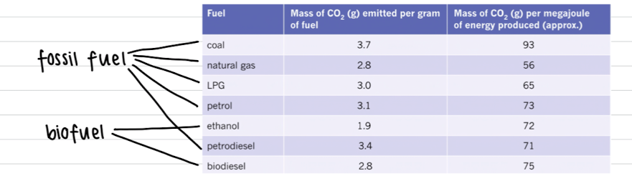

TABLE 11.3.4 PAGE 252

(summary of energy content (kJg-1) for different fuels)

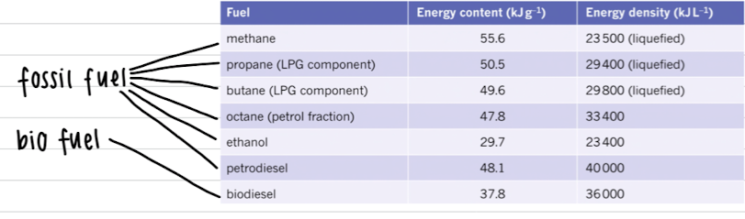

TABLE 11.2.2 PAGE 239 - OTHER EMISSIONS

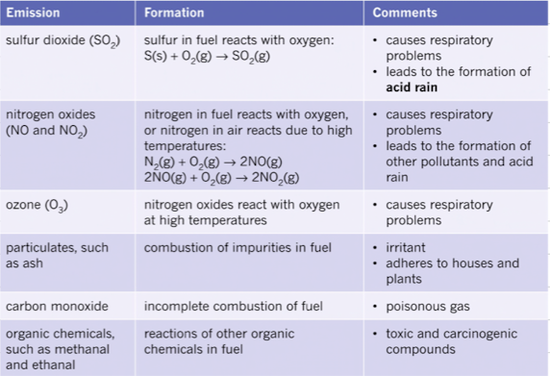

# INTERMOLECULAR FORCES

SHAPES OF MOLECULES

VSEPR

* the VSEPR theory is used to predict the shape of molecules (and polyatomic ions)

**V**alence

**S**hell

**E**lectron

**P**air

**R**epulsion theory

This means that...

Valence electrons (in pairs) will repel each other and therefore they will be arranged

as far away from each other as possible

* some of these electron pairs are the shared electrons in a covalent bond
* as the shared electrons move as far apart as possible, the atoms move with them

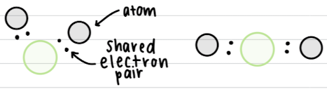

* lone pairs also repel other electrons and also contribute to the shape of the molecule
  + the repulsion of lone pairs is greater than the repulsion of shared electrons
  + ∴ they push the other electrons away more than shared electrons

MOLECULES WITH 2 ATOMS

(diatomic molecules)

* in molecules with 2 atoms, the shared electrons lie between the 2
* the atoms will be in a straight line
  + linear shape

MOLECULES WITH MORE THAN 2 ATOMS

* in molecules with more than 2 atoms, we look at the number of electron groups surrounding the central atom
* these electron groups will be as far apart as possible
* remember: that this will be in 3 dimensions

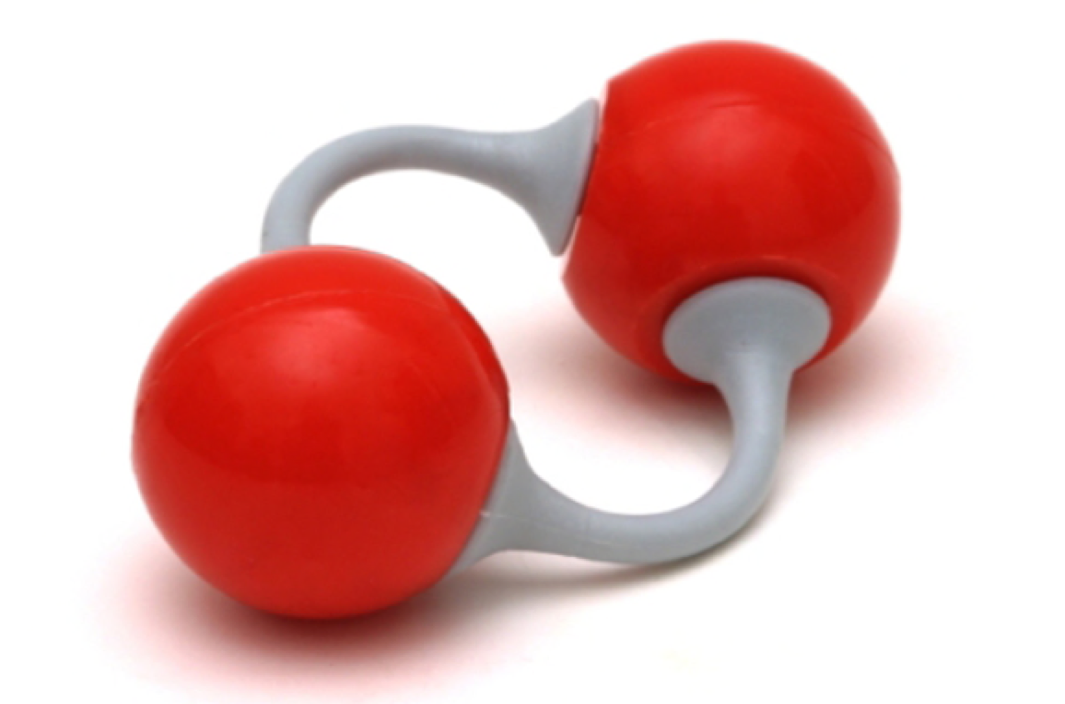

MOLECULES WITH 2 GROUPS OF ELECTRONS AROUND THE CENTRAL ATOM

* if there are 2 groups of atoms around a central atom, the electron groups will arrange themselves on opposite sides of the central atom
* the atoms on either side will be 180° from each other in a
* linear shape

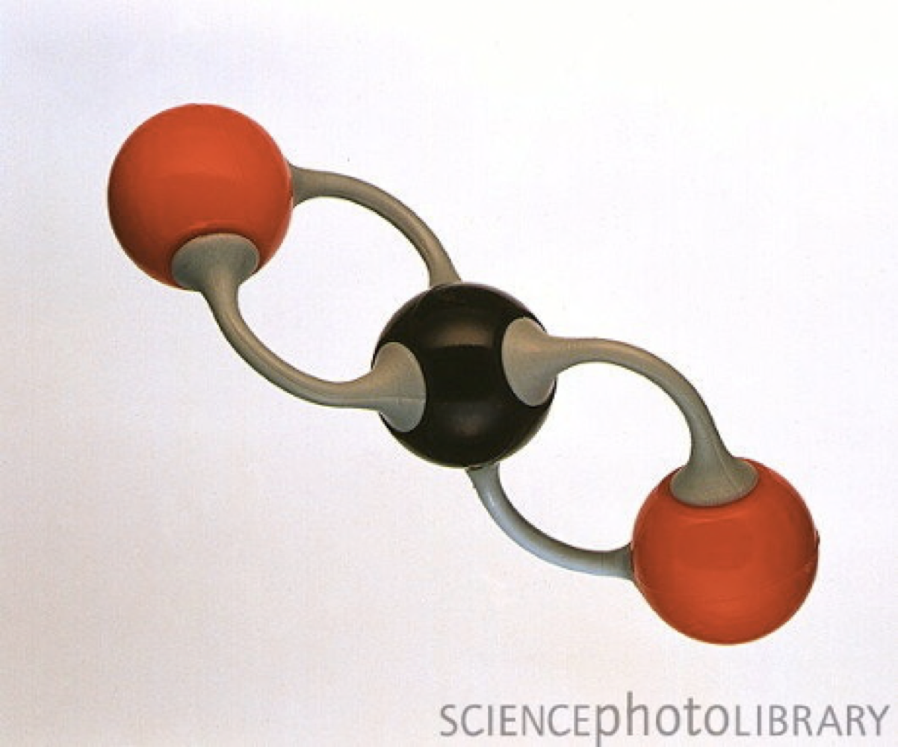

MOLECULES WITH 3 GROUPS OF ELECTRONS AROUND THE CENTRAL ATOM

* if there are 3 groups of atoms around the central atom, the groups will arrange themselves 120° apart
* the atoms will be arranged in a trigonal planar shape

MOLECULES WITH 4 GROUPS OF ELECTRONS AROUND A CENTRAL ATOM

* if there are 4 groups of atoms around the central atom, the groups will arrange themselves 109.5° apart
* the electrons will be arranged in a tetrahedral shape
* however: the shape of the molecule will depend on the number of bonding pairs and lone pairs
* it all the electron pairs are bonding pairs. there will be atoms attached to each of them in a tetrahedral shape
* if 3 of the electron pairs are bonding pairs and 1 is a lone pair, there will be 3 atoms attached in a pyramidal shape
* if 2 of the electron pairs are bonding pairs and 2 are lone pairs, there will be 2 atoms attached in a bent triatomic shape

tetrahedral, pyramidal, pyramidal shape (in order of the images)

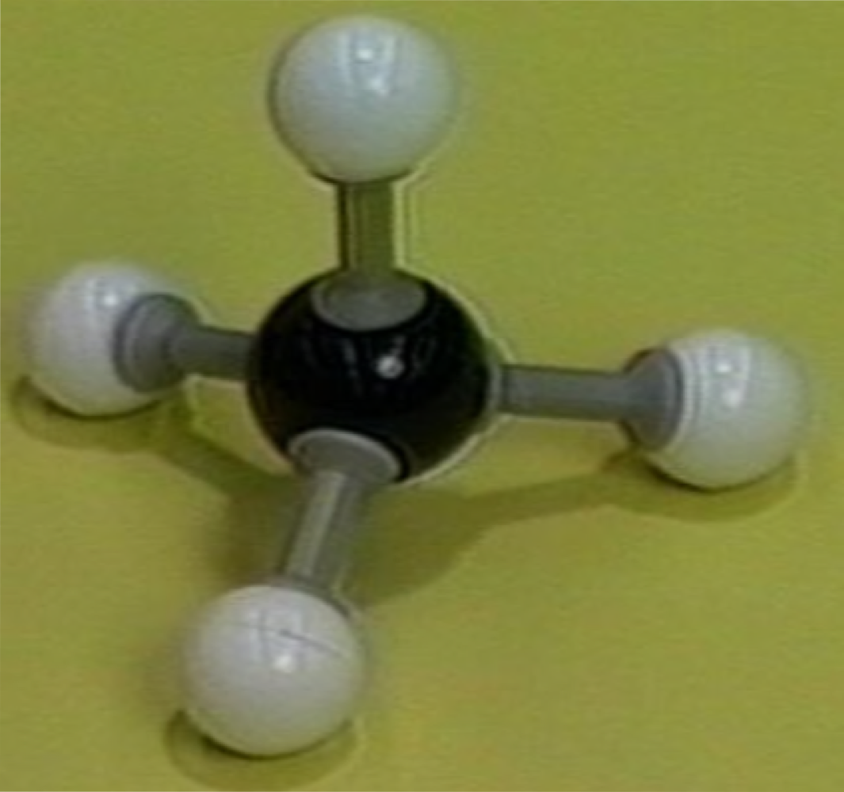 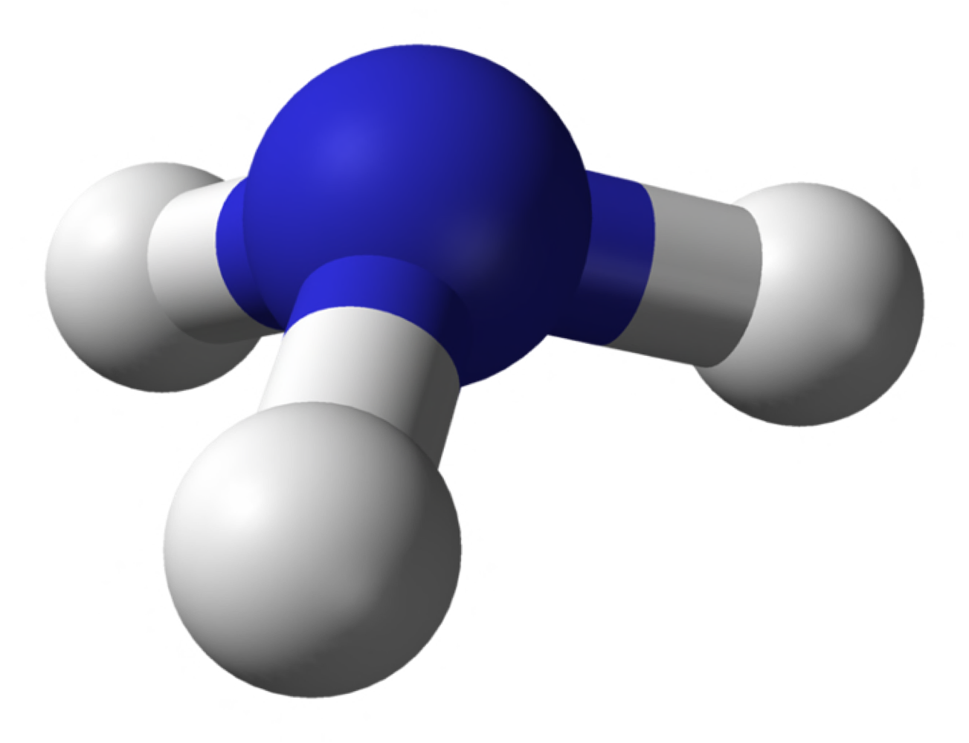 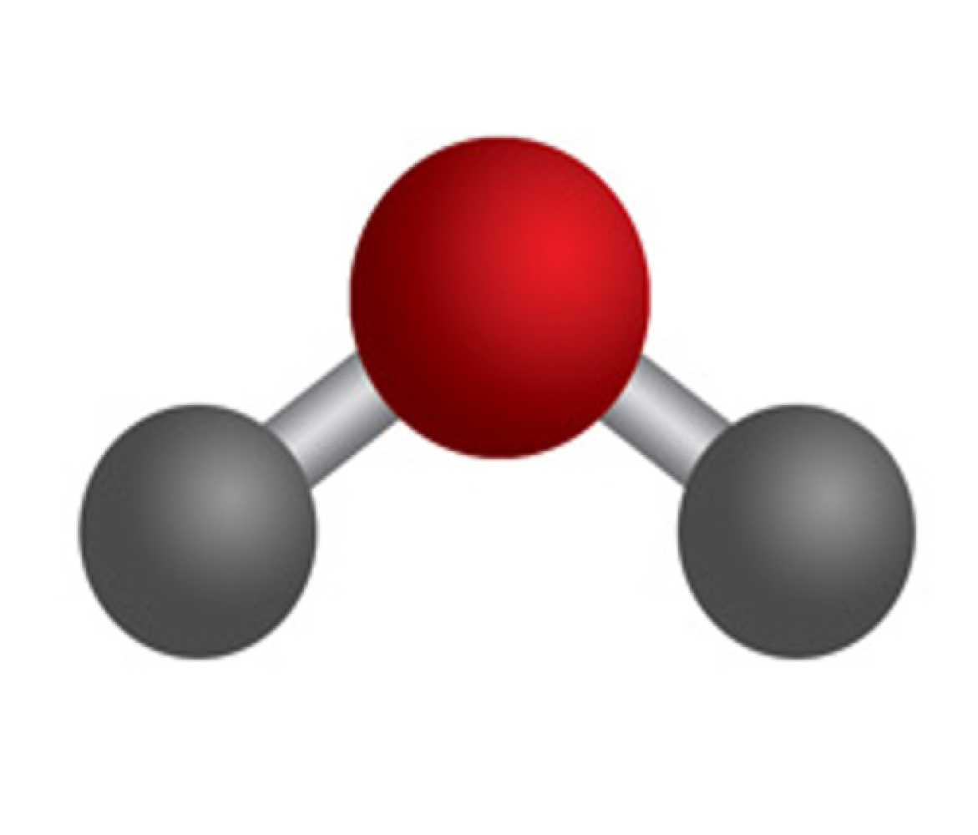

# ELECTRONEGATIVITY AND POLARITY

ELECTRONEGATIVITY

* a measure of the ability of an atom to attract electrons in a covalent bond
* electronegativity trends: increases up and across the P.T

POLAR + NON-POLAR BONDS

* atoms with the same electronegativity will share bonding electrons equally
  + this forms a 'pure' non-polar covalent bond
* diatomic molecules of an element (e.g. O2) contain non-polar bonds because both atoms are the same
* atoms with very similar electronegativities (such as carbon and Hydrogen) also form bonds which are considered to be non-polar
* atoms with a difference in electronegativity between 0-5 and 1-8 generally form covalent bonds but do not share the bonding electrons equally
  + this means they form polar covalent bonds
* the shared electrons spend more time closer to the element that is more electronegative
* ∴ when two atoms form a polar bond, one of the atoms has a slight negative charge (ẟ- = delta negative) and one atom has a slight positive charge (ẟ+ = delta positive)
* the separation of charges is called a bond dipole

POLAR MOLECULES, NON-POLAR MOLECULES + POLARITY

* polarity is the measure of how polar a molecule or bond is:
  + the greater the difference in the positive and negative ends of the dipole, the greater the polarity of the molecule
* the polarity of diatomic molecules (such as Ck and HCl) can be determined by the difference in electronegativity of the atoms
* the polarity of molecules with more than 2 atoms (such as Hao and CO2) can be determined by looking at the:
  + polarity of the covalent bonds and
  + the shape of the molecule

note: as a general rule, symmetrical molecules are non-polar and asymmetrical molecules

are polar

# INTRAMOLECULAR + INTERMOLECULAR

INTRAMOLECULAR VS INTERMOLECULAR

* intra: forces that hold atoms within a molecule/compound i.e. ionic, covalent and metallic bonds)
* inter: forces that exist between covalent molecules

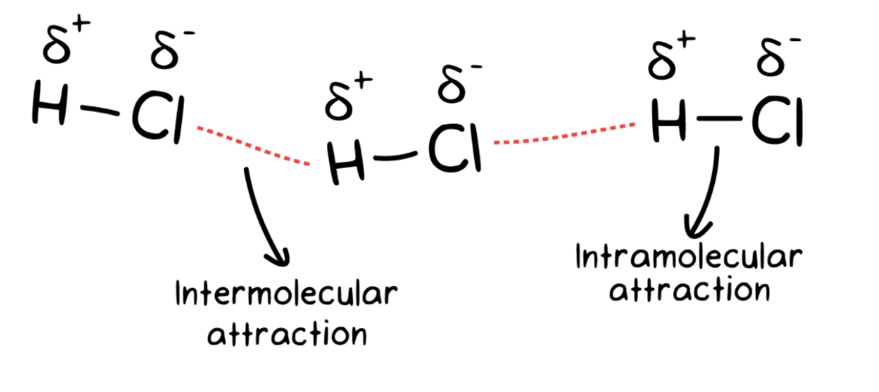

TYPES OF INTERMOLECULAR FORCES

Dipole-Dipole Force

* only occur in polar molecules
* exist due to an attraction between the positive and negative ends of adjacent polar molecules
* relatively weak because the partial changes in a dipole are small
* the more polar a molecule (the greater the difference in the partial positive and partial negative ends of the molecule) the stronger the dipole-dipole forces

Hydrogen Bonding

* oxygen, nitrogen and fluorine are all highly electronegative
* when these atoms bond to hydrogen, they form a very polar bond
  + ie. the hydrogen will have a relatively large partial positive charge (δ+)
* this results in a strong attraction between the partially positive hydrogen and the lone pairs of electrons on oxygen, fluorine or nitrogen on an adjacent molecule

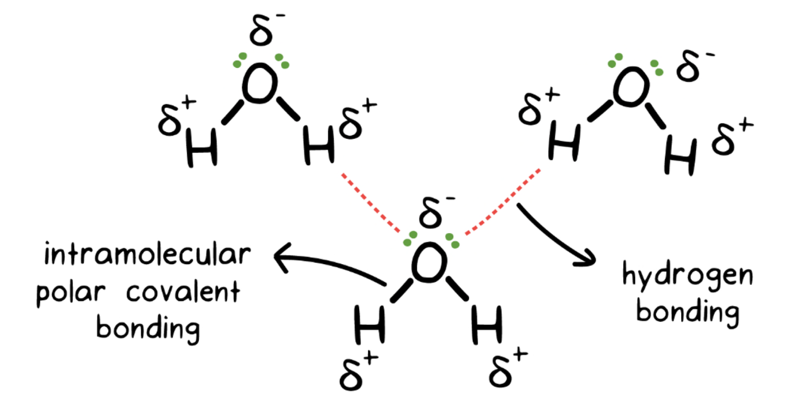

Dispersion Forces

* the weakest type of intermolecular force, yet all molecules have dispersion forces between them
  + this explains the existence of intermolecular forces in non-polar substances despite the lack of a dipole
* occur due to movement of electrons
* at a particular moment, there will be more electrons at one end of a molecule compared to the other end
* this causes a temporary or instantaneous dipole
* the temporary dipole on one molecule will induce a temporary dipole on an adjacent molecule
* the opposite charges will then be attracted to each other
* size and shape of molecules has an effect on strength of dispersion forces:
  + larger molecules have a larger number of electrons, this would mean stronger dispersion forces (e.g. F2 vs I2)
  + molecules that form long chains have stronger dispersion forces due to a large surface area (e.g. butane vs methyl propane)

STRENGTH OF INTERMOLECULAR FORCES

* in general, the strength of the intermolecular forces is:

dispersion < dipole-dipole < hydrogen bonds

* but, as shown earlier, this may vary depending on the number of electrons and the shape of the molecule

PHYSICAL PROPERTIES AND INTERMOLECULAR FORCES

Vapour pressure

* The measure of the tendency for a substance to evaporate, or more accurately….
* The measure of the pressure exerted (in kPa) by the gas particles that escape from the surface of a liquid when it is in a closed container
* The stronger the intermolecular forces, the lower the vapour pressure and vice versa
  + When the molecules are held together by strong forces, there is less of a tendency to evaporate and less pressure exerted
* As temperature increases, vapour pressure increases (due to an increase in kinetic energy)
  + molecules can escape their intermolecular forces easier as temperature increases, therefore increasing the vapour pressure

Melting and boiling point

* To melt or boil, a covalent molecular substance needs to overcome the intermolecular forces
* The stronger the intermolecular forces, the more energy needed to overcome the forces – therefore the higher the melting and boiling point
* In general, dispersion forces are the weakest intermolecular force and hydrogen bonds are the strongest
* However, dispersion forces have their own trends in melting and boiling point due to size and shape of molecules (see previous examples)
* The boiling point is the temperature where the vapour pressure is equal to atmospheric pressure (therefore the liquid turns to vapour)
* Trends in boiling point are identified the same way as the trends in melting point

Solubility

* The ability of a substance to dissolve
  + The substance that dissolves is the solute, the substance that it is dissolved in is the solvent
* Covalent molecular substances do not break into individual atoms (like ionic compounds) when they dissolve
* The intermolecular forces are disrupted in the solute and solvent, this separates the individual covalent molecules that make up the substance
* Both the solute and the solvent need to have strong enough intermolecular forces to be able to disrupt each others’ forces
* Generally speaking, covalent molecular substances with similar intermolecular forces will be soluble in one another

For example:

* Non-polar substances with strong dispersion forces will be soluble in other non-polar substances with strong dispersion forces because the intermolecular forces in the solute and solvent will be disrupted
  + Polar substances with hydrogen bonding will be soluble in other polar substances with strong hydrogen bonding for the same reason

# GASES

KINETIC THEORY OF GASES

* Theory which is used to explain the behaviour of gases.
* Assumes that gases are made up of particles in constant motion.
* The theory uses the model of an **ideal gas** – a gas that conforms to the theory perfectly
* No real gases would behave in a completely ideal manner, but “close enough is good enough” in this situation

The kinetic theory of gases proposes that:

1. Gases consist of tiny molecules or atoms
2. The particles move in rapid, straight line motion
3. The average distance between particles is very large compared with the size of the particle
4. Intermolecular forces are negligible
5. The particles collide with each other and the walls of a container
6. All collisions are elastic (no energy is lost)
7. The average kinetic energy increases as the temperature increases

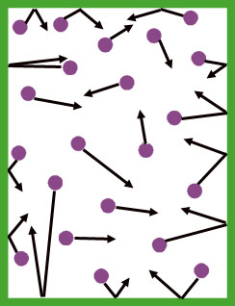

PHYSICAL PROPERTIES OF GASES

* The kinetic theory is used to explain the properties of gases.
* E.g. Diffusion - gases rapidly diffuse as the particles are moving rapidly and continue to move until they hit something
* E.g. Compressibility - gases are compressible as there is a large amount of space between the particles

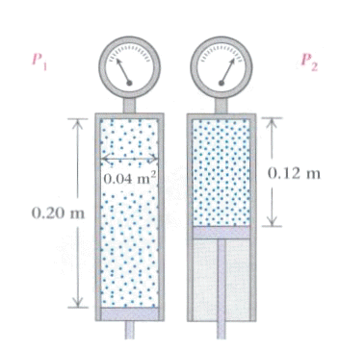

PRESSURE

* When gas particles hit the walls of the container they exert a force
* Pressure is force exerted by the gas particles over a given area
* E.g. We feel gas pressure due to the collisions with our skin.
* E.g. The pressure in balloons is due to the collisions with the material of the balloon
* Gas pressure is measured in kilopascals (kPa), atmospheres (atm) or millimetres of mercury (mm Hg)
* We know that:

1 atm = 101.3 kPa = 760 mmHg

* This is known as atmospheric pressure (pressure exerted by atmospheric gases at sea level)
* Therefore we can convert between the units for pressure using a ratio
* For example, to convert 105 kPa to atmospheres:

1 atm = 101.3 kPa

x atm = 105 kPa

∴ 1/x = 101.3/105

∴ x = 1 × 105 / 101.3

∴ x = 1.04 atm

TEMPERATURE

* Temperature is a measure of the average kinetic energy of the particles
* The temperature of gases is measured in Kelvin (K)
* 0°C = 273.15 K

Therefore:

Degrees Celsius + 273.15 = Kelvin

Kelvin – 273.15 = Degrees Celsius

VOLUME

* Volume is the 3 dimensional space that a substance occupies
* Volume is commonly measured in litres (L), millilitres (mL), cubic metres (m3) or cubic centimetres (cm3)
* 1 mL = 1 cm3 and 1000 L = 1 m3

PRESSURE AND VOLUME

* Assuming that temperature remains the same…
* When the volume of a gas is decreased the particles are closer together
* This means that there will be more collisions per unit of area
* Therefore pressure will increase

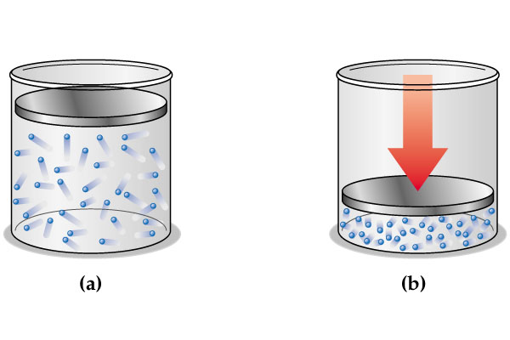

* This means that pressure and volume are inversely proportional to each other – as one increases the other decreases by the same factor

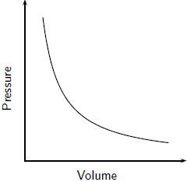

TEMPERATURE AND PRESSURE

* Assuming that volume remains the same…
* When the temperature of a gas is increased the average kinetic energy increases
* Therefore, the particles are moving faster
* This means that the particles will collide with the container more frequently, and with more force
* Therefore the pressure will increase
* This means that temperature and pressure are directly proportional to each other – as one increases the other also increases

TEMPERATURE AND VOLUME

* Assuming that pressure remains the same…
* When the temperature of a gas is increased the average kinetic energy increases
* Therefore, the particles are moving faster
* If the pressure remains the same, there needs to be more volume for the particles
* This means that temperature and volume are directly proportional to each other – as one increases the other also increases

# HLPC AND GAS CHROMATOGRAPHY

COLUMN CHROMATOGRAPHY

* A column is filled with a substance that acts as the stationary phase (e.g. silica beads)
* The sample to be separated is pipetted into the top of the column
* A solvent, or mixture of solvents, (called an **eluent**) is poured into the column
* The sample will dissolve and adsorb as the eluent moves through the column
* The sample is separated into its components based on the interactions with the stationary and mobile phase
  + The components that interact strongly with the stationary phase moves more slowly
  + The components that has weaker interactions with the stationary phase moves faster
* The eluent is collected in fractions as it exits the column
* The fractions collected will contain the different components of the sample

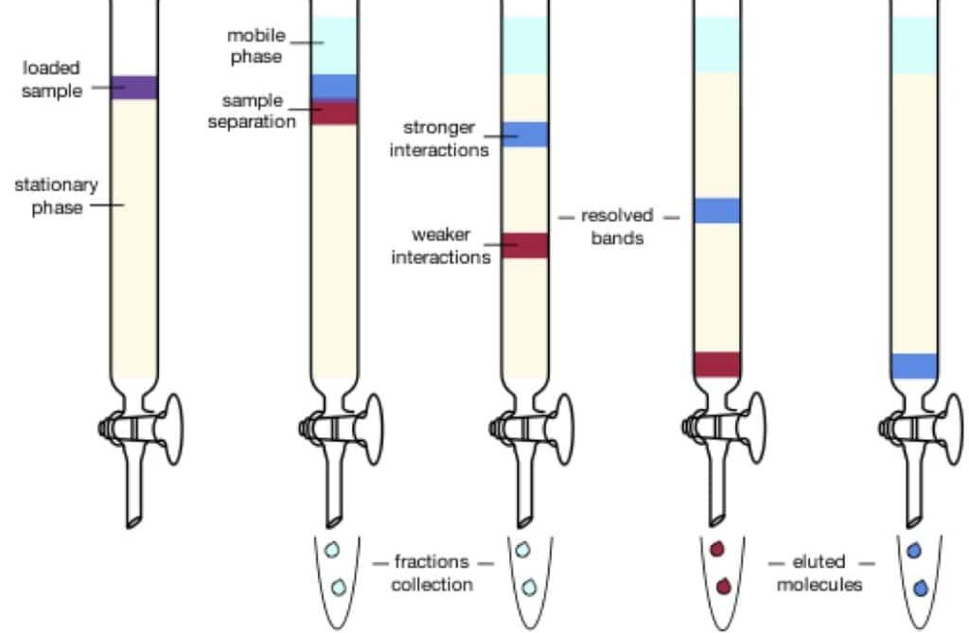

HIGH PERFORMANCE LIQUID CHROMATOGRAPHY (HLPC)

* A technique based on column chromatography
* The particles for the stationary phase are very small, this increases the amount of adsorption and desorption (this results in better separation)
* The solvent has to be pumped through the column under high pressure (the process is sometimes called high pressureliquid chromatography)
* The separated components are passed through a detector (usually a beam of UV light)
* The detector records the component as a peak on a chromatogram that is usually recorded on a computer

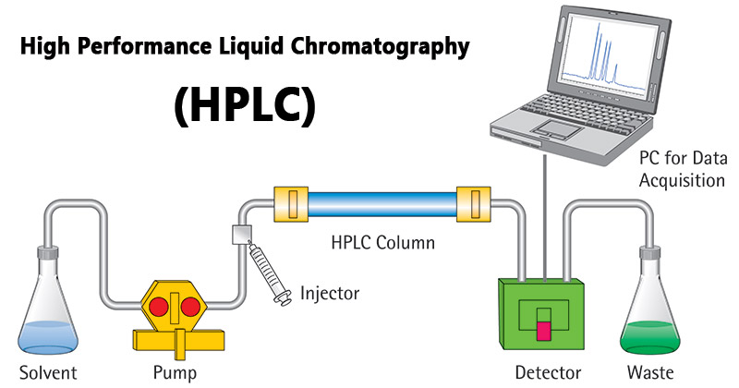

GAS CHROMATOGRAPHY (GC)

* A very sensitive analytical technique – can detect tiny amounts of components in a sample
* The mobile phase is an unreactive gas (e.g. nitrogen)
* The sample is injected into a column, and is heated and vaporised
* The column is packed with the stationary phase (either a solid coated with an adsorbent liquid or an adsorbent solid like silica gel)
* Components that adsorb least strongly to the stationary phase will be swept out first by the gas in the mobile phase
* The components are picked up by a detector and a chromatogram is recorded on a computer

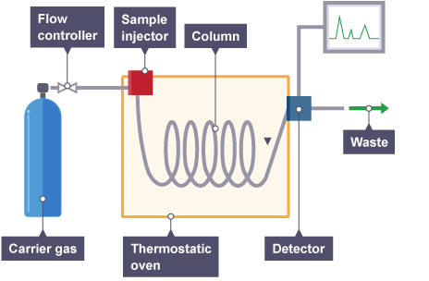

INTERPRETING CHROMATOGRAMS FROM HLPC AND GC

* The retention time(Rt) is the time taken for the component to pass through the column in GC and HPLC
* The shorter the retention time, the less it adsorbed to the stationary phase (i.e. it moved faster through the column)
* The peak tells you the amount of the component in the sample (bigger peak = more of that component in the sample)
* The retention time of known substances (obtained under the same conditions) can be compared with the components on a chromatogram of an unknown substance
  + This will allow identification of each component (a qualitative analysis)
* The concentration of a component in a sample can also be determined (quantitative analysis)
  + The peak areas of chemicals with a known concentration can be plotted on a calibration curve
  + The peak area of the same chemical from a sample being analysed can then be ‘measured against’ the calibration curve to determine the concentration (see example p296 in textbook)

# WATER

STRUCTURE OF WATER AND HYDROGEN BONDING - A RECAP

* H2O (dihydrogen monoxide)
* Bent (v-shaped) due to VSEPR
* Polar (has a net dipole)
* Main IMF betweenwater molecules is hydrogen bonding
* Hydrogen bonding is the force of attraction between the partially positive hydrogen atoms and the lone pairs on the oxygen atoms
* This electrostatic attraction is relatively strong compared to other IMF

UNIQUE PHYSICAL PROPERTIES OF WATER

Relatively high melting and boiling point

* Compared to molecules of a similar size (e.g. H2S or HF)
* The hydrogen bonding between molecules means the energy needed to overcome the forces is high
* Because of the potential of one water molecule to form up to four hydrogen bonds with surrounding water molecules this increases the energy needed to overcome all the forces to turn water into a liquid or gas

Density in solid and liquid phases

* When water cools the molecules slow down (decrease in kinetic energy)
* They arrange themselves so that each molecule forms 4 H-bonds with the adjacent molecules
* This increases the space between the molecules and therefore increases the volume of the frozen water (ice)
* This makes ice less dense than liquid water, so it floats

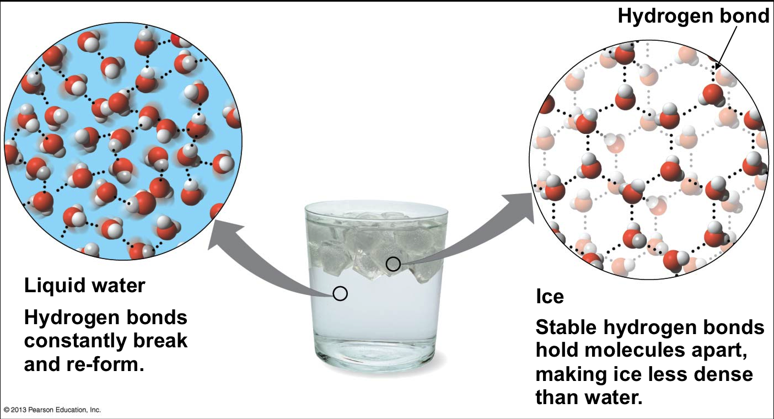

Surface tension

* The measure of the resistance of a liquid to increasing its surface area
* Water has a relatively high surface tension due to strong intermolecular forces
* The water molecules at the surface only form H-bonds with the water molecules next to them and below them
* There is no/minimal force of attraction in an outward direction – the cohesive forces are greater than adhesive forces
  + this creates a net force pulling the molecules down/in
* The strong attraction means they have a tendency to stay in shape – resisting forces that disrupt them
* This creates a tension that makes the surface of the water behave like a thin, stretched skin
  + Because the water molecules on the surface are so attracted to each other by strong hydrogen bonds

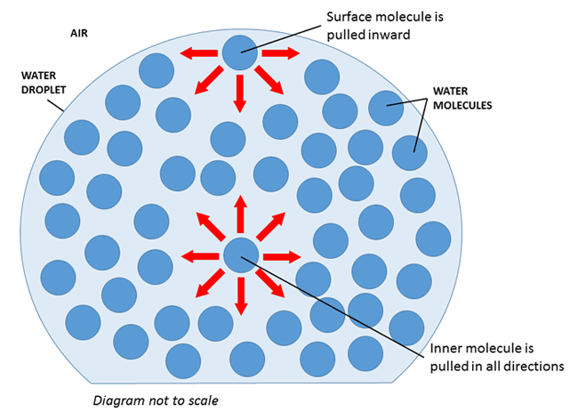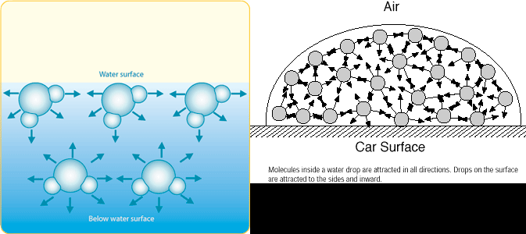

Other things in your textbook/from other sources that might be useful to know about but aren’t in the syllabus dot point:

* Cohesive properties (the molecules all want to stick to each other, this helps explain surface tension)
* Adhesive properties (molecules stick to other surfaces, which explains capillary action of water and other liquids)
* High heat capacity (water takes a lot of energy before there is a change in temperature compared to other substances)
* Latent heat of vaporisation (water needs a lot of potential energy to make a change from liquid to gas)

# SOLUTIONS

SOLUTIONS

* A solution is a homogenous mixture (uniform composition)
* A solution is formed when a solute dissolves in a solvent
  + The solute will be present in a smaller amount compared to the solvent
* When a solution contains the maximum amount of solute is it saturated
* If a solution contains less than the maximum amount of solute it is unsaturated
* Under certain conditions more than the maximum amount of solute can be dissolved
* These solutions are called supersaturated and are very unstable
  + This is usually achieved by dissolving the solute in a hot solvent then allowing it to cool
* An aqueous solution is formed when a solid, liquid or gas dissolves in water (i.e. water is the solvent)

DISSOLUTION – THE PROCESS OF DISSOLVING

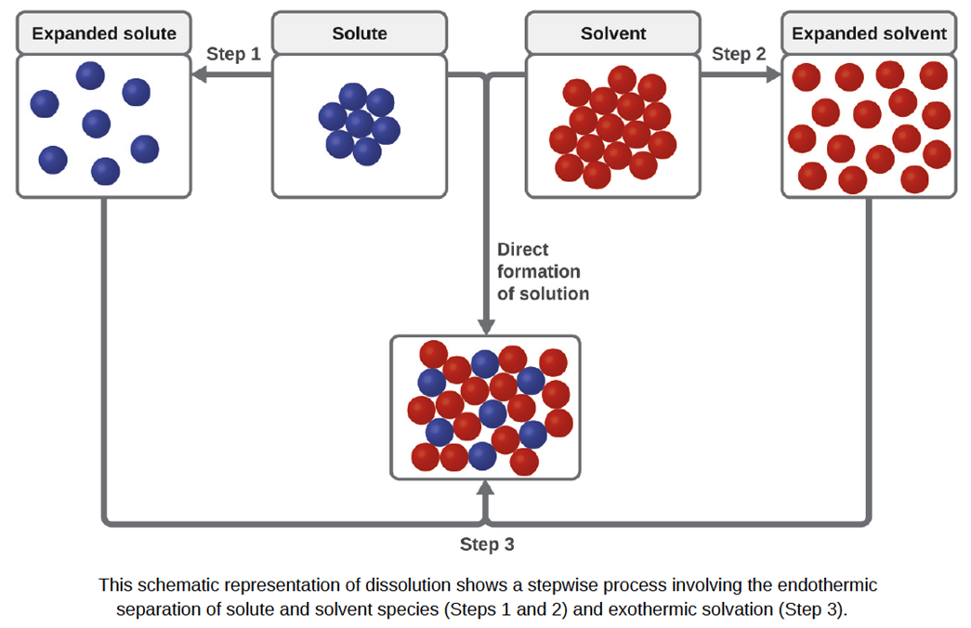

DISSOLVING

* Forces of attraction hold the particles of the solute together before it dissolves
* Forces also hold the particles of the solvent together (in water these forces are hydrogen bonds)
* For a substance to dissolve, the attractive forces between the solute and solvent must be strong enough to overcome the forces holding together the solute and solvent particles
* When the bonds (or forces) between solute molecules and the bonds between solvent molecules are broken, energy must be put in
* When the bonds form between solute and solvent molecules, energy is released
* If the energy released is greater than the energy needed to break the bonds then the solute will dissolve in the solvent
* The dissolution process results in an even distribution of solute and solvent particles in a mixture
* Polar solvents (such as water) will generally dissolve ionic compounds and polar covalent molecular substances
* Non-polar solvents can generally dissolve non-polar covalent molecular substances

WHY SOME SUBSTANCES DISSOLVE IN WATER

* Some covalent molecular substances will form hydrogen bonds with water (e.g. glucose, sucrose or ethanol in solution)

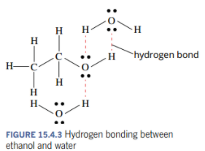

* Some covalent molecular substances will go through the process of ionisation
  + When the substance dissolves in water it forms ions.
  + As the ions were not there in the first place, they are actually being produced.
* This occurs because of a strong force of attraction between the water molecules and the separate atoms of a substance
* E.g. HCl ionises in water to form hydrogen ions and chloride ions
  + HCl(g) + H2O (l) 🡪 H+(aq) + Cl-(aq)
* Ionic substances go through the process of dissociation
  + Where the ions separate in a solvent to form a solution
  + This is not ionisation, because the ions were already there and have simply moved apart
* This happens due to ion-dipole interactions
  + The attraction between ions and a polar molecule such as water
* E.g. when NaCl dissolves in water (see whiteboard for further explanation)

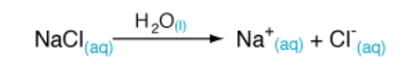

SUSPENSION

* When an insoluble substance is put into a liquid it will not dissolve
  + This means that there are solid particles in the liquid
  + These particles are often heavier than the liquid, and so they sink to the bottom
* This mixture is called a suspension

SOLUBILITY

* Solubilityis the amount of a solute that can dissolve in a solvent at a given temperature.
* The solubility of a substance will vary with temperature.
* Generally, as the temperature increases:
  + The solubility of a salt (ionic compound) will increase
  + The solubility of non polar gases will decrease

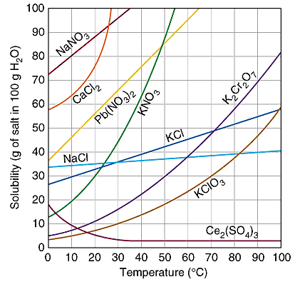

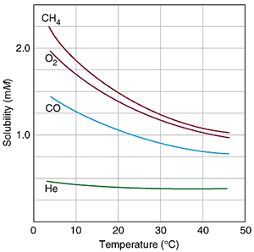

CONCENTRATION

* Solubilityis the amount of a solute that can dissolve in a solvent at a given temperature.
* Concentrationis the amount of a solute that is dissolved in the solvent in a solution.
* Diluteandconcentrated are 2 words used to qualitatively describe the concentration of a solution.
* A dilute solution is one in which there is a small amount of solute in a large amount of solvent.
* For example the sugar in a cup of tea.
* A concentrated solution is one in which there is a large amount of solute dissolved in a small amount of solvent.
* For example undiluted cordial.

ELECTROLYTES

* An electrolyte is a substance that forms ions in water, and can therefore conduct electricity as a solution.
* It refers to the solute that does dissolve, and whether when it dissolves it forms ions or not.

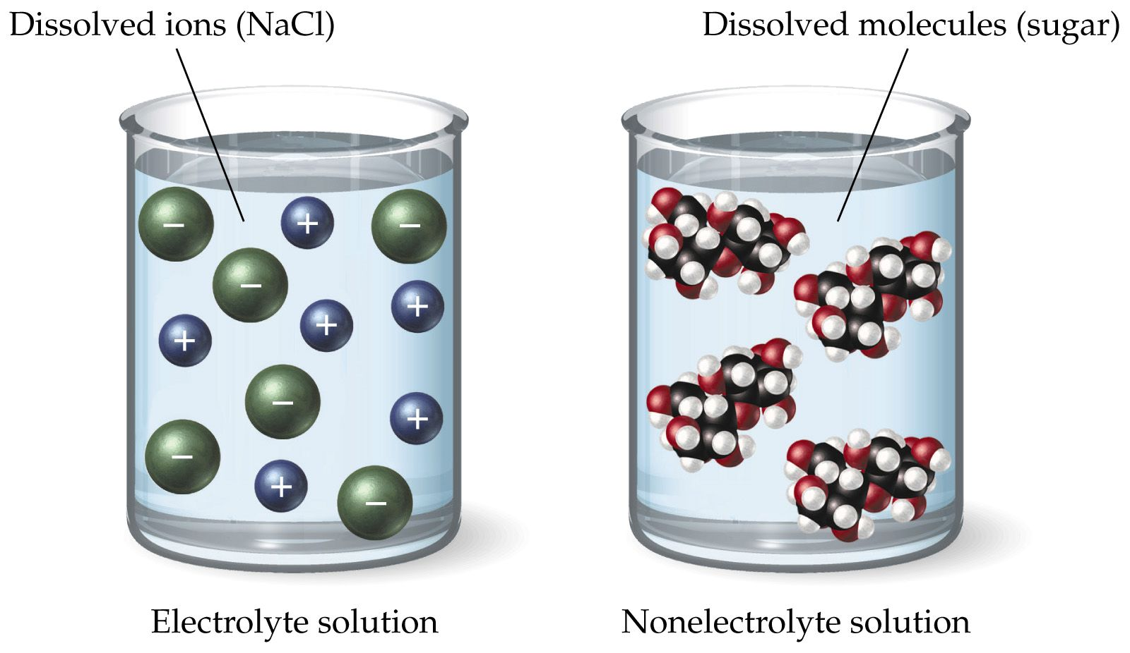

STRONG ELECTROLYTES

* If all of the substance that has dissolved forms ion it is called a strong electrolyte.
* Ionic compounds are all strong electrolytes as they will fully dissociate, forming ions, when they dissolve.
* Even an insoluble ionic substance is a strong electrolyte as the very small amount that does dissolve will all break up into the ions.
* Some molecular compounds are strong electrolytes.
* For example hydrochloric acid (HCl) and sulfuric acid (H2SO4) will all ionise to form positive hydrogen ions and a negative ion (Cl- or HSO4-).

WEAK ELECTROLYTES

* A weak electrolyte is a substance where only a small percentage of the dissolved substance will form ions.
* Some molecular compounds are weak electrolytes.
* For example, a small amount of acetic acid will ionise to form acetate and hydrogen ions when it dissolves.
* We often write these ionisation equations with a double arrow to show that not all of it will form the ions.
* For example: acetic acid ionising in water:
  + CH3COOH 🡨🡪CH3COO- + H+

NON ELECTROLYTES

* Some molecular compounds will not form any ions when they dissolve.
* These are called non-electrolytes as they will not conduct electricity.
* Sugar is an example of a non-electrolyte.

PRECIPITATES

* When 2 ionic solutionsare combined some combinations of ions will not be soluble.
* Because they are insoluble, they will form a solid or precipitate
* The precipitate will tend to settle on the bottom after it has formed

SOLUBILITY TABLES OR RULES

* There are some generalisations or rules as to what combinations of ions will form a precipitate.
* These are found on your data sheet.

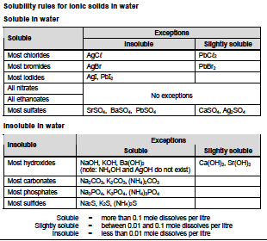

* To determine whether a precipitate will form, consider all the ions that will be in the solution.
* Look at each combination of anion and cation.
* Use the solubility table to identify if any of these combinations will be insoluble.
* If it is insoluble, it will not dissolve, and therefore will form a precipitate.
* For example: A solution of barium nitrate is mixed with a solution of sodium sulfate.
  + Anions: nitrate, sulfate
  + Cations: barium, sodium
  + Combinations: barium sulfate, sodium nitrate (the original combinations can be discounted as they were already a solution)
  + Barium sulfate is insoluble, therefore it will form a solid.

COLOURS OF SOLUTIONS

* Certain ions give characteristic colours in a solution or as a solid.
* Key colours are listed on your data sheet.
* Ions that produce colourless solutions, form white solids. These are not listed on the data sheet.
* Generally the colour of the coloured ions in solution will be the same as the solid.

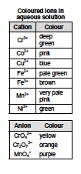

* Some ions will form a different colour when it is a solid to when it is solution.
* Some of these exceptions are listed on your data sheet.

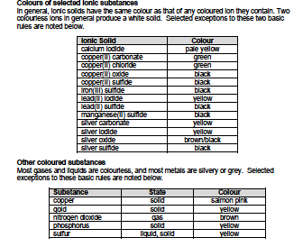

# ACIDS AND BASES

ACIDS

* Acids have the following properties:
  + Tasting sour
  + Corrosive
  + Turn blue litmus red
  + Have a pH of less than 7
  + Can form electrolytes in solution (and conduct electricity)
* Common examples of acids:
* Hydrochloric acid is HCl
* Sulfuric acid is H2SO4
* Nitric acid is HNO3
* Carbonic acid is H2CO3
* Phosphoric acid is H3PO4
* Ethanoic acid is CH3COOH

THE ARRHENIUS MODEL OF ACIDS

Arrhenius proposed that an acid is a substance that will produce hydrogen ions in solution.

* For example:
* HCl (aq) 🡪 H+ (aq) + Cl- (aq)

BASES

* Bases have the properties of:
  + Tasting bitter
  + Being corrosive
  + Turning red litmus blue
  + Having a pH of greater than 7
  + Can form electrolytes in solution and conduct electricity
  + Bases that are able to dissolve in water are called alkali and form an alkaline solution
* Common examples of bases:
  + Sodium hydroxide (NaOH)
  + Magnesium hydroxide (Mg(OH)2)
  + Sodium oxide (Na2O)
  + Ammonia (NH3)

THE ARRHENIUS MODEL OF BASES

Arrhenius proposed that a base is a substance that will produce hydroxide ions in solution.

* For example:
* NaOH (aq) 🡪 Na+ (aq) + OH- (aq)

pH

* pH is a measure of the concentration of hydrogen ions [H+]
* An increase in pH by 1 represents a decrease in the concentration of hydrogen ions by a factor of 10.
  + pH = -log[H+]
* At 25OC
  + A neutral solution (equal concentration of hydronium and hydroxide ions) has a pH of 7
  + An acidic solution (concentration of hydronium is greater than hydroxide) has a pH less than 7
  + An alkaline solution (concentration of hydroxide is greater than hydronium) has a pH greater than 7

INDICATORS

* An indicator is a chemical that has different colours in different pH’s
* Most indicators will have 2 colours
  + For example: litmus, phenolphthalein, bromothymol blue
* Universal indicator is a combination of a number of indicators and therefore has a wider range of colours

STRENGTH OF ACIDS AND BASES

The strength of an acid or base is determined by the extent to which it will form ions in solution.

In a strong acid all the molecules will form hydrogen ions in solution.

In a strong base all the molecules will form hydroxide ions in solution.

In a weak acid only some of the molecules will form hydrogen ions in solution

In a weak base only some of the molecules will form hydroxide ions in solution.

* A strong acid or base will produce more ions in solution, therefore it will have a greater electrical conduction than a weak acid or base of the same concentration.
  + Therefore, an acid or base that forms a strong electrolyte in solution will have a higher electrical conductivity
* The pH of an aqueous solution of an acid or base is determined by the concentration of hydrogen ions
* The higher the concentration of hydrogen ions the lower the pH
* Therefore, the strength of the acid or base will alsoaffect the pH, as it will affect the concentration of hydrogen ions
* The stronger the acid the lower the pH
* The stronger the base the higher the pH

Strong acids to know:

HCl – hydrochloric acid

H2SO4 – sulfuric acid

HNO3 – nitric acid

Weak acids to know:

CH3COOH – acetic acid/ ethanoic acid

H3PO4 – phosphoric acid

H2CO3 – carbonic acid

Strong bases to know:

Group 1 and 2 hydroxides eg. NaOH

Weak bases to know:

NH3 – ammonia

Na2CO3 – sodium carbonate



STRENGTH VS CONCENTRATION

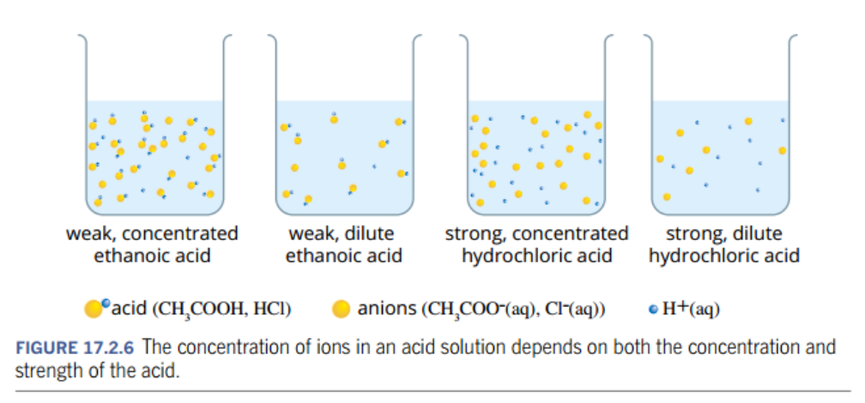

SALTS

* Salts are ionic compounds. E.g. NaCl and MgSO4
* A salt can be produced when an acid and a base react.
  + The anion comes from the acid
  + The cation comes from the metal in the other reactant.
* The anions produced from acids are:
  + Chloride (Cl-) from hydrochloric acid (HCl)
  + Sulfate (SO42-) from sulfuric acid (H2SO4)
  + Nitrate (NO3-) from nitric acid (HNO3)
  + Phosphate (PO43-) from phosphoric acid (H3PO4)
  + Carbonate (CO32-) from carbonic acid (H2CO3)
  + Ethanoate (CH3COO-) from ethanoic acid (CH3COOH)
* Examples of salts include:
  + Sodium nitrate
  + Calcium sulfate
  + Aluminium chloride
  + Magnesium acetate (or magnesium ethanoate)

REACTIONS OF ACIDS

* Acid + metal hydroxide 🡪 salt + H2O
* Acid + metal oxide 🡪 salt + H2O
* Acid + reactive metal 🡪 salt + H2
* Acid + carbonate 🡪 salt + CO2 + H2O
* Acid + hydrogencarbonate 🡪 salt + CO2 + H2O

REACTIONS OF BASES

* Base (a metal hydroxide or oxide) + acid 🡪 salt + H2O
* Base + ammonium salts 🡪 salt + H2O + NH3

# REACTION RATES

MEASURING RATE OF REACTION

* A **rate** is how quickly one quantity changes compared to another
* In a chemical reaction the **rate of reaction** is defined as the amount of reactants used up **or** the amount of products formed in a given time
$\text{rate of reaction = }\frac{\text{amount of substance used or produced}}{\text{time taken}}$

* It can be measured by the change in one measurable quantity over the change in time.
* Measurable quantities for chemical reactions include:
  + mass
  + colour
  + volume
  + pH
  + concentration

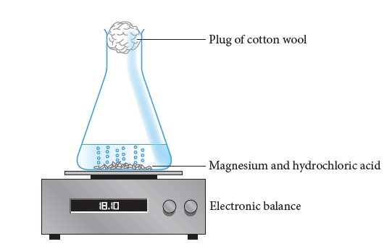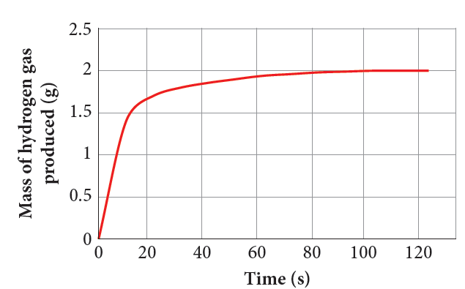

* A graph can show the changes during a reaction.
* The gradient represents the rate of reaction showing how quickly the reactants or products change.

[THE COLLISION THEORY](https://sites.prairiesouth.ca/legacy/chemistry/chem30/2_kinetics/kinetics2_1.htm)

For a chemical reaction to occur:

1. The reacting molecules must collide with one another
2. The collisions must occur with enough energy to disrupt the bonds in the reactants (known as activation energy – Ea)
3. The molecules must collide with the correct orientation

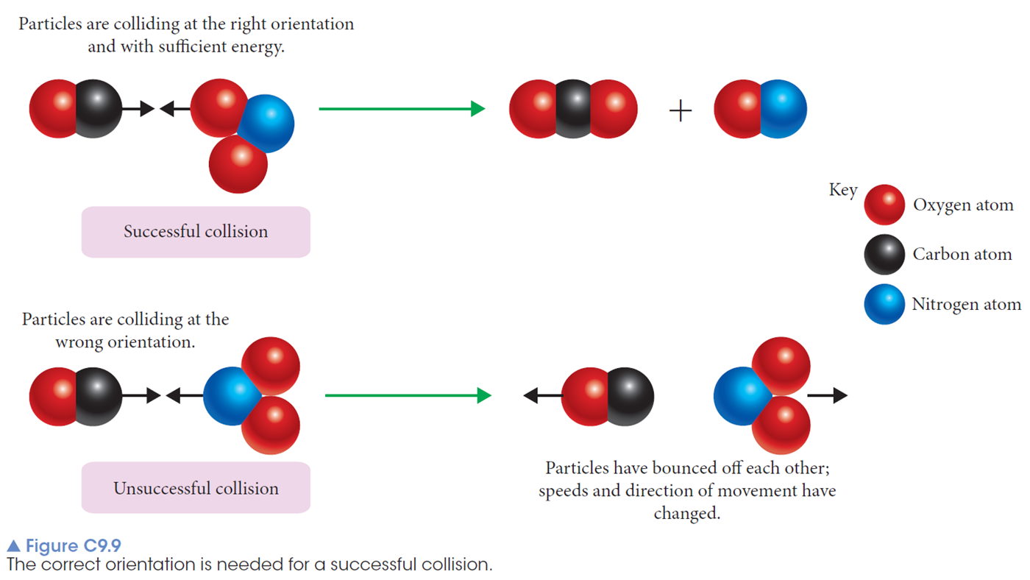

* A successful collisionhas sufficient energy and an appropriate orientation to allow the bonds in the reactants to be broken and new bonds to be formed.
* An unsuccessful collisionis one in which the energy and/or orientation are not satisfactory.
* The more successful collisions there are in a given time, the faster the rate of the reaction (because more reactants are forming products)
* The number of successful collisions depends on the:
  + total number of collisions/frequency of collisions
  + percentage of collisions that are successful

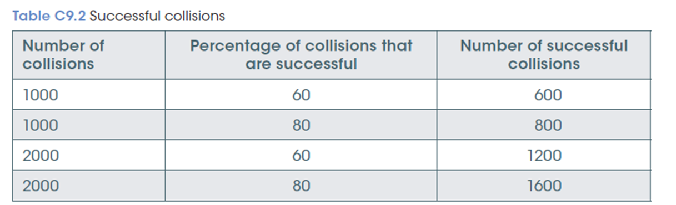

**Note:** Changing the rate of a reaction will not change the amount of product formed, only the time it takes to form it

ENERGY PROFILE DIAGRAMS

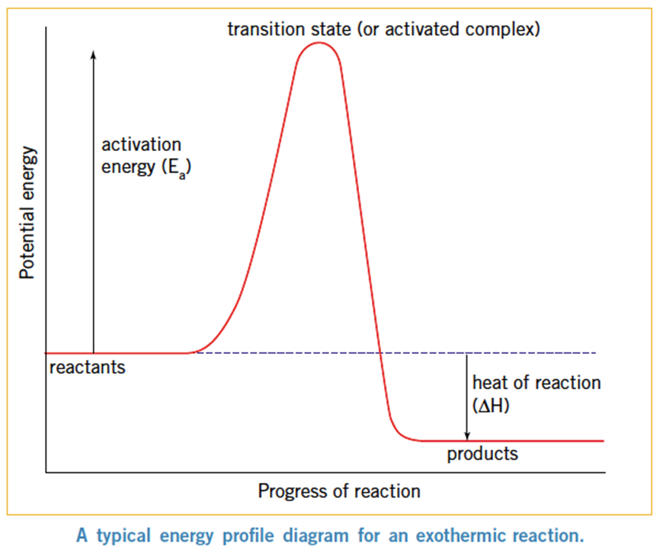

* This minimum energy that a collision needs to break the bonds of the reactants is the activation energy (Ea)
  + The activation energy is measured from the enthalpy of the reactants to the top of the peak
* The peak is referred to as the transition state/activated complex– bond breaking and bond forming are both occurring at this stage - it is a very unstable state
* The energy released after the transition state goes into forming the products
* The enthalpy change (Δ*H*) of a reaction is the difference in energy between the reactants and the products
  + A negative Δ*H* means it is an exothermic reaction
  + A positive Δ*H* means it is an endothermic reaction

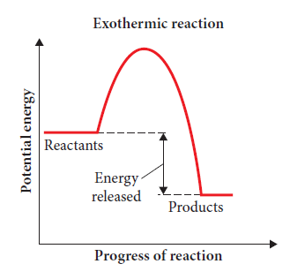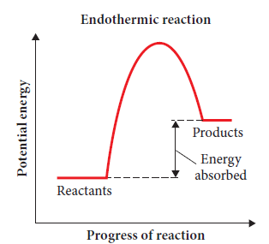

ANALYSING ENERGY PROFILE DIAGRAMS, AN EXAMPLE:

For the forward reaction

* 2H2(g) + O2(g) →  2H2O(l)
  + 1. the reaction is exothermic
    2. the heat of reaction, △H, is -572 kJ
    3. the activation energy, is Ea kJ

FACTORS THAT AFFECT REACTION RATES

1. Nature of reactants

* If the bonds of the reactants only require a small amount of energy to break, the activation energy will be low.
* A larger number of particles will have enough energy for a successful collision.
* Therefore there are more successful collisions in the same time - the reaction rate increases.

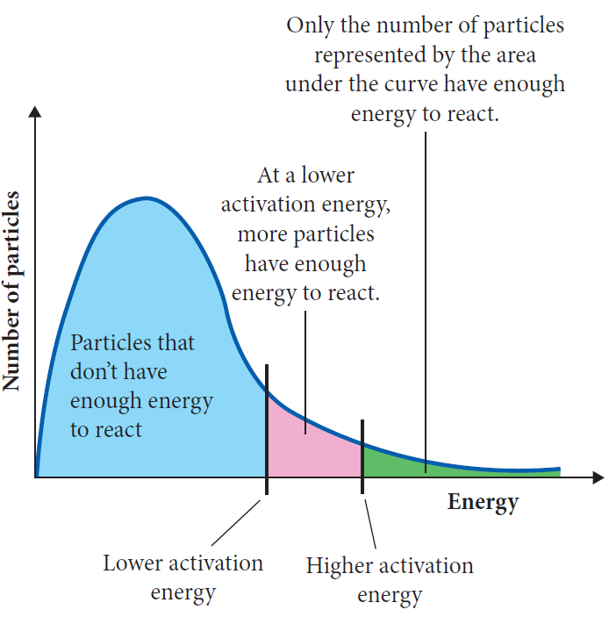

1. Concentration and pressure

* Concentration measures the number of particles in a certain volume of a solution.
* When the concentration increases, there will be a greater number of reactant particles in a given volume
* This will increase the **frequency** (and therefore the total no.) of collisions between reactants in a given time
* Therefore, although the percentage of collisions that are successful remains the same, the higher frequency of collisions will lead to an increase in no. of successful collisions - the reaction rate increases.
* Increasing the pressure of a gas in a container will increase the no. of gas molecules in a given volume (increase the concentration of gas molecules)
* This will also lead to more frequent collisions, and therefore a higher number of successful collisions – increasing reaction rate

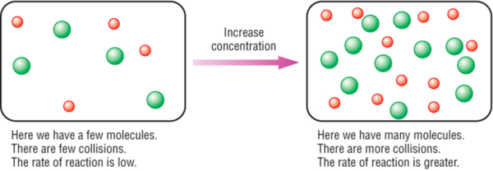

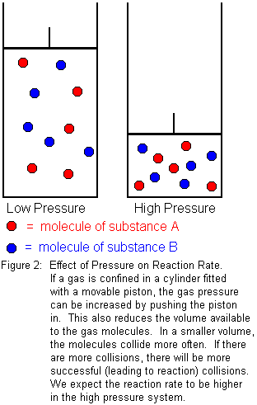

1. Surface area

* A reaction can only take place between particles that can collide.
* In a solid, only the exterior particles are available to react.
* By dividing a solid mass into smaller pieces, some interior particles are now exposed and therefore are available to react - the total surface area has been increased.

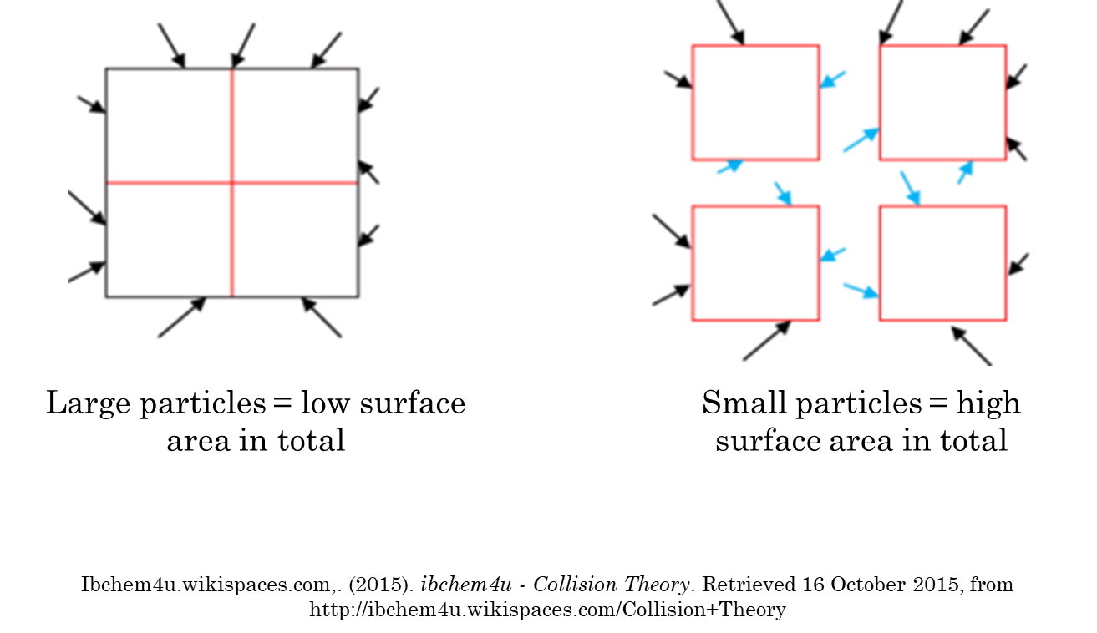

* This will increase the frequency of collisions that occur.
* Therefore there will be an increase in the number of successful collisions in the same time - the reaction rate will increase.

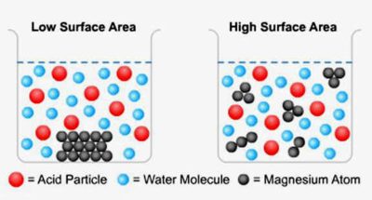

1. Temperature

* At a given temperature, particles of a substance will have different amounts of kinetic energy, with the average kinetic energydetermining the temperature.
* The higher the temperature the greater the average kinetic energy.
* This means that more particles will have enough energy to have a successful collision, therefore a higher percentage of collisions are successful.
* This means there will be more successful collisions in the same time - reaction rate increases.
* At the higher temperature the particles are also moving faster due to the higher kinetic energy.
* Therefore there will be more collisions/a higher frequency of collisions.
* However, this increase in speed has only a small affectcompared with the increased average kinetic energy.

Only those particles with the activation energy, or greater, will have enough energy to break the bonds of the reactants and have a successful collision.

MAXWELL-BOLTZMAN DISTRIBUTION

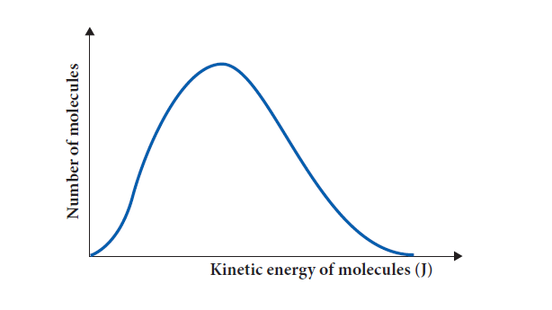

* A graph that shows:
  + the number of particles present in a chemical reaction
  + how much energy those particles have
  + The area under the curve represents the sum of all the particles involved in the reaction
* A certain point on the x-axis will represent the activation energy required for the particles involved in the chemical reaction
* Only those particles with the activation energy, or greater, will have enough energy to break the bonds of the reactants and have a successful collision.

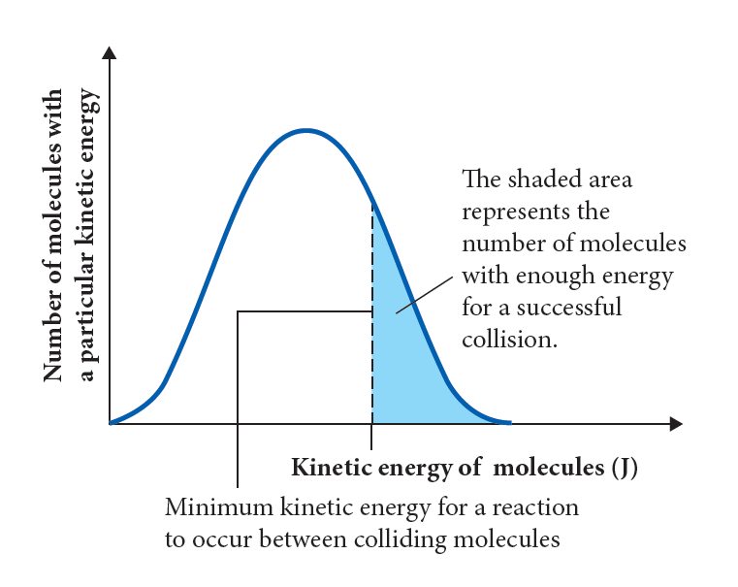

* At a given temperature, if the activation energy is lower in one chemical reaction compared to another then more particles will have sufficient energy to successfully collide and react



* When the temperature is increased the distribution of particles with a particular kinetic energy changes
  + Because of the increase in the average kinetic energy
* This shows how **more particles** now have sufficient energy for a successful collision at this increased temperature
  + because the area under the curve from the activation energy and higher will be bigger

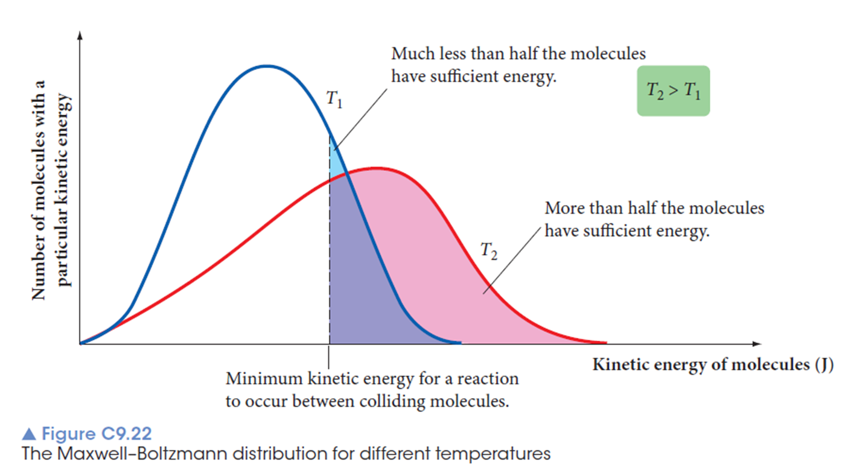

1. Catalysts

* A catalyst is a substance that alters the rate of a reaction without being consumed (or used up) in the reaction
* A catalyst works by providing an alternative pathway for a reaction.
* A positive catalyst provides an easier pathway with a **lower activation energy**
* This means that more particles will have sufficient energy for a successful collision.
  + the percentage of collisions that are successful is increased.
* Therefore there are more successful collisions in the same time - the reaction rate increases

Affect of catalyst shown in an energy profile diagram:

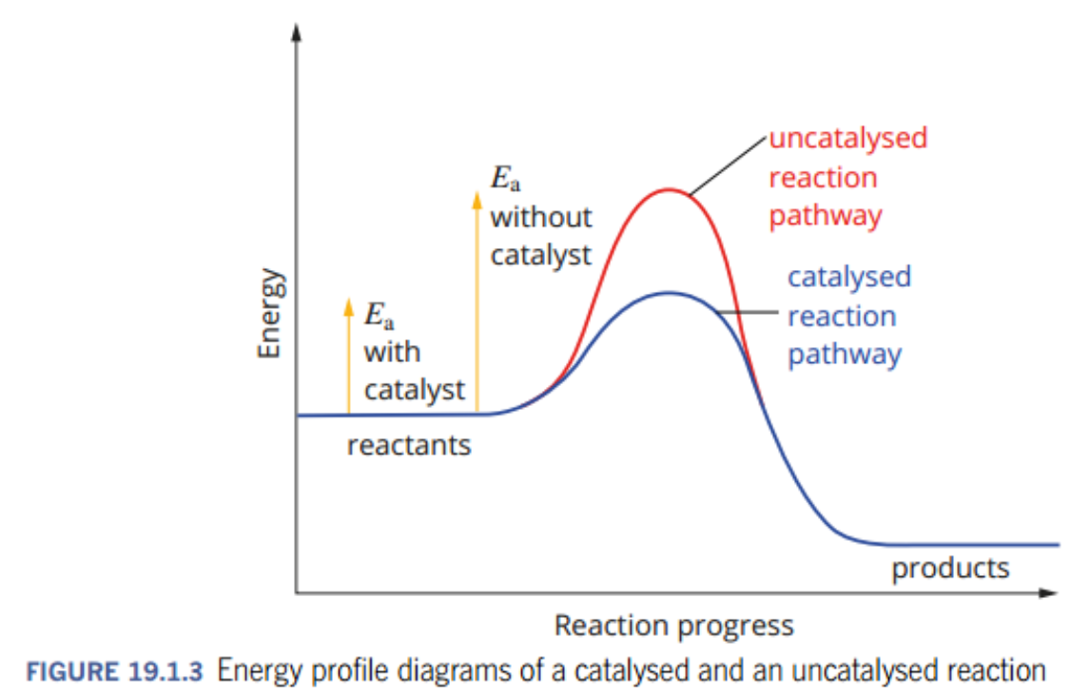

Affect of catalyst shown in a Maxwell-Boltzmann distribution graph:

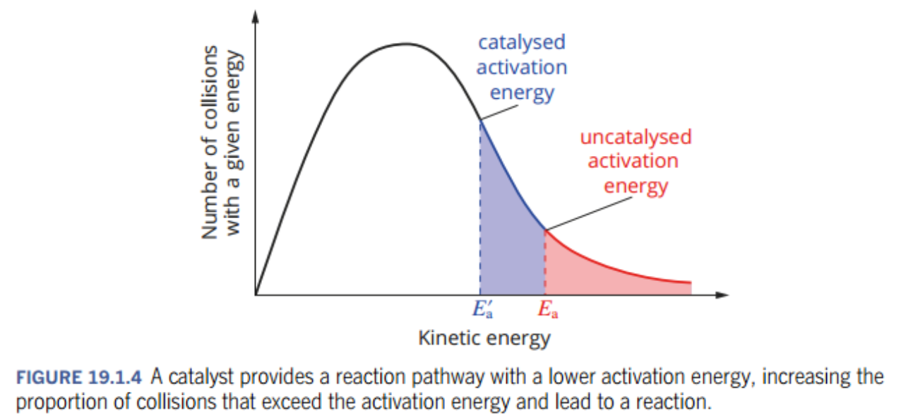

# TYPES OF CATALYSTS

ENZYMES

* Large, organic molecules called proteins that act as biological catalysts
* Have specifically shaped sections called active sites
  + The active site the part of the enzyme that interacts with the reactants in a chemical reaction
* The reactant(s) that attach to the active site of an enzyme are called substrates
* The substrate forms weak intermolecular force with the active site – forming an enzyme-substrate complex
* The bonds in the substrate are more easily rearranged in this complex, causing quick formation of products (reduced activation energy and increased rate of reaction)
* The new products are released and the enzyme is left in its original form

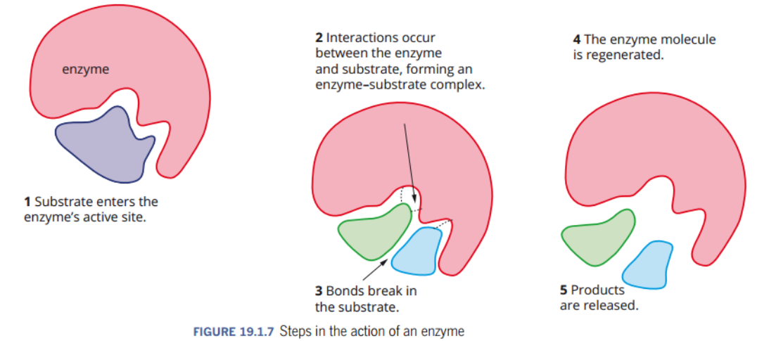

* Enzymes can produce much faster reaction rates than inorganic catalysts
* Enzymes are much more specific in the reactions that they can catalyse
* Enzymes are more sensitive to pH and temperature changes than inorganic catalysts

METAL NANOPARTICLES

* Nanoparticles (particles with a diameter between 1 – 100 nm) have a very large surface area
* Optimising the surface area of a catalyst means a large amount of reactants can access the catalyst, having a greater impact on reaction rate
* Research into a number of different metal nanoparticles, including gold and copper as catalysts for fuel cells, is currently occurring

CATALYSTS IN INDUSTRY

* In order to maximise efficiency and speed up reactions that would be uneconomically slow, catalysts are often used in industrial processes.
* E.g. a metal catalyst (iron) is used in the production of ammonia – a substance that is used in the production of modern-day fertilisers
* Catalysts such as these make industrial processes more cost effective
  + by increasing rate of reaction at a lower temperature, it means less energy is required for the process

CATALYTIC CONVERTERS

* Catalytic converters are used in cars to reduce air pollutants
* A catalytic converter is placed between the engine and the exhaust pipe and contains a mixture of metals over a large surface area
* As the toxic products from the burning of fuels (carbon monoxide and nitrogen oxide) come into contact with the catalyst, they are converted to non-toxic gases (carbon dioxide and nitrogen gas)
  + 2NO(g) 🡪 N2(g) and O2(g)
  + 2CO(g) + O2(g) 🡪 CO2(g)

